**Data Management Lab Guide**

Table of Contents

**IMPORTANT...!! MUST Read Before You Begin** 3

(A) Avoiding Overcharges 3

(B) Standardization for Evaluations 4

**1.** **Provisioning and Deploying Azure SQL** 5

1.1 Setting up the Azure SQL Database 5

1.2 Connecting to the Azure database using DBeaver 12

1.3 Connecting Azure database to Microsoft SQL Server Management Studio 14

1.4 Connecting to the deployed AzureSQL database via Azure Portal 16

1.5 Hands-on Database Exercises 17

1.6 Please don’t forget to pause/delete/terminate the service when you are done 18

**2.** **Provisioning and Deploying Azure MYSQL flexible** 19

2.1 Creating an Azure MySQL database 19

2.2 Connecting to the database using DBeaver 24

2.3 Connecting to the database with MySQL Workbench 26

2.4 Connecting to the database with integrated Azure Bash Shell 28

2.5 Hands-on Database Exercise 29

**3.** **Provisioning and Deploying Azure Database for PostgreSQL** 30

3.1 Setting up PostgreSQL Database 30

3.2 Connecting to the deployed PostgreSQL database using DBeaver 35

3.3 Hands-on Database Exercise 37

4 Implementing a No SQL Databases in Azure– Cosmos DB 38

No SQL DATABASES 38

Provisioning Azure Cosmos DB NoSQL 40

Creating data item 1: 47

Creating data item 1: 48

Query Data 49

**Annexure I (Budgets and Alerts)** 52

**Annexure II (Software Installation Manual)** 55

(a) DBeaver Enterprise Edition 55

(b) Microsoft SQL Server Management Studio 60

(c) MySQL Workbench 60

# **IMPORTANT...!! MUST Read Before You Begin**

(A) Avoiding Overcharges

on any cloud platform involves careful planning, monitoring, and optimization of your resources. Ignorance and carelessness can often lead to unanticipated costs, which are, at times, very high.

Here are some tips to help you avoid getting overcharged on Azure:

1. **Monitor Usage and Costs:**
   1. Regularly monitor your Azure usage and costs using the Azure portal or Azure Cost Management and Billing.
   2. Set up alerts for cost thresholds to receive notifications when costs are approaching or exceeding predefined limits. Instruction in Annexure I.
2. **Budgets and Forecasts:**
   1. Set up budgets in the Azure portal to receive alerts when your spending is nearing predefined thresholds. Instructions in Annexure I.
   2. Utilize Azure's forecasting tools to estimate future costs based on your current usage.
3. **Rightsizing Resources:**
   1. Always use the right-size resource. For most development activities minimal resource configuration is sufficient. Optimize virtual machine sizes, storage configurations, and other services to match your actual needs.
   2. If you are unsure of your hardware needs, consider using auto-scaling. Auto-scaling adds more resources to your service or environment when needed. For example, with the auto-scaling option ticked, more CPU cores, RAM or SSD will be added automatically should the need arise.   
      This ensures you are billed for resources that you have actively utilized, avoiding downtimes and unnecessary costs associated with provisioning more resources than needed.
   3. Consider using tools like Azure Advisor for recommendations on optimizing your resources.
4. **Resource Tagging:**
   1. Use resource tagging to categorize and track costs for specific projects, departments, or purposes. This helps you understand where your money is going and allocate costs appropriately.
5. **Delete services when no longer in use:**
   1. One may forget about the provisioned server or service, and it keeps running unnecessarily for days until you see your exorbitant bill. To avoid this, **DELETE** the services when you no longer need them.   
      YOU MUST DELETE ALL THE SERVICES BEFORE THE TERM ENDS OR WHEN YOU NO LONGER NEED THEM.
   2. **PAUSE/STOP**: If you have a service running and you plan to catch some sleep or continue after a couple of days, you can use the PAUSE OR STOP option available in most of the services. This may save you a significant cost.
6. **Use a Strong Password and 2FA:** 
   1. It is not uncommon to see attacks on Cloud service accounts. Hackers are always on the lookout for weaknesses. They may do Bitcoin mining or other resource-intensive tasks. Please protect yourself by using a very strong password.
   2. Always use two-factor authentication whenever possible.

## (B) Standardization for Evaluations

**Students are expected to standardize the following parameters across the labs whenever possible:**

|  |  |
| --- | --- |
| **Parameter** | **Recommended Convention** |
| Resource Group | Comp2702YourFirstName |
| DatabaseName | Comp2702ServiceNameYourFirstName |
| Server | US WEST |
| Username | YourFirstName |
| Tag | YourFirstName |
| Value | ServiceName |

Table 1: Standardization

# **Provisioning and Deploying Azure SQL**

Azure SQL is a cloud-based relational database service provided by Microsoft Azure. It supports various SQL Server features, offering scalable and fully managed database solutions for applications. Users can deploy and manage SQL databases in the Azure cloud, benefiting from features like automatic backups, high availability, and security measures. Azure SQL is compatible with various programming languages and tools.

Agenda:

* To create a database using Azure SQL.
* Connecting to the database using Microsoft SQL Server Management Studio
* Connecting to the database using DBeaver
* Connecting to the Database using Azure Portal
* Exercises with Database

Future: Integration with analytics softwares: powerBI, Tableau

## Setting up the Azure SQL Database

Figure 1: Login to the Azure portal, click on Create a Resource

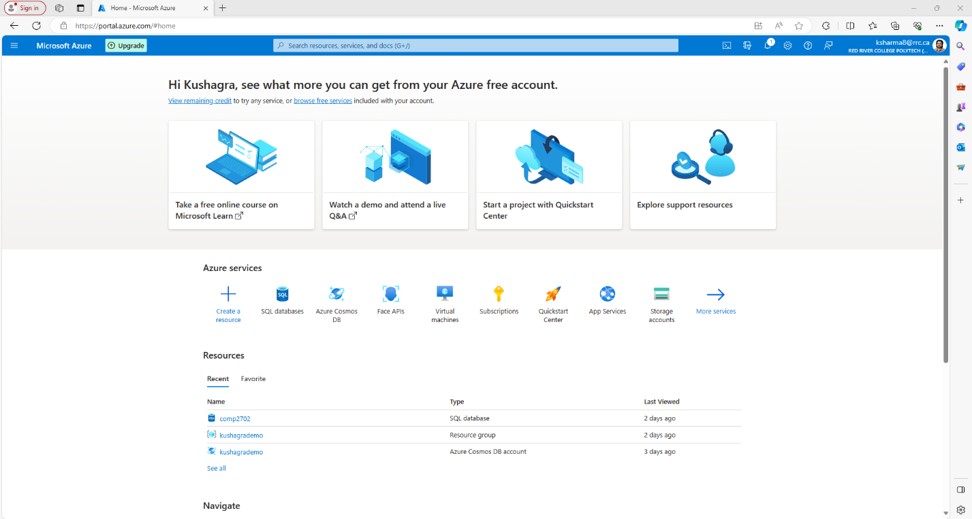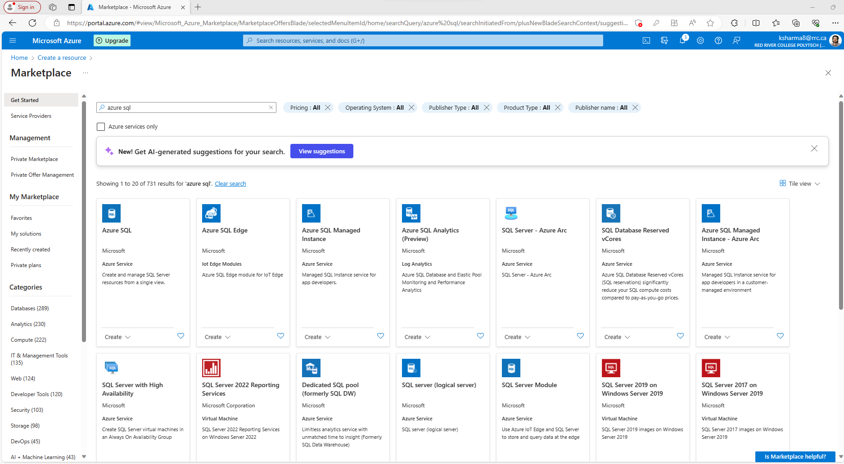

Figure 2: Search for Azure SQL

Figure 3: Select Azure SQL and click create.

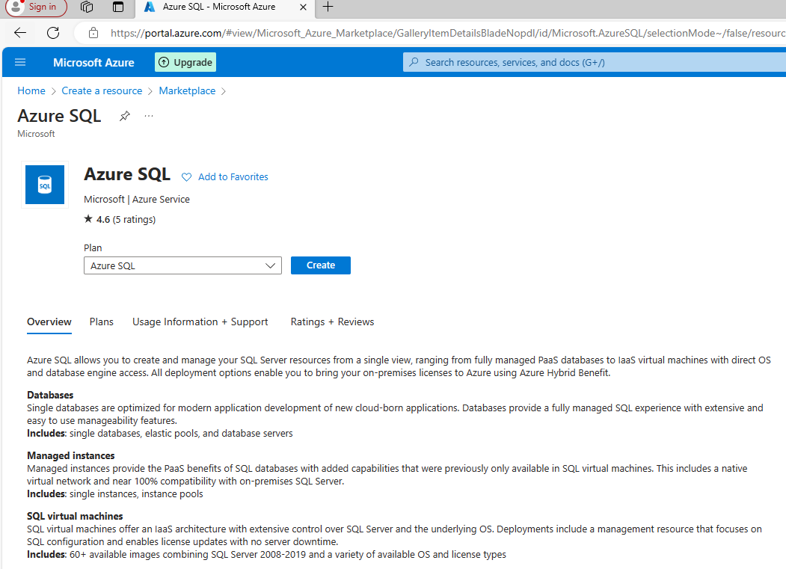

Figure 4: Select Single Database and Click on Create

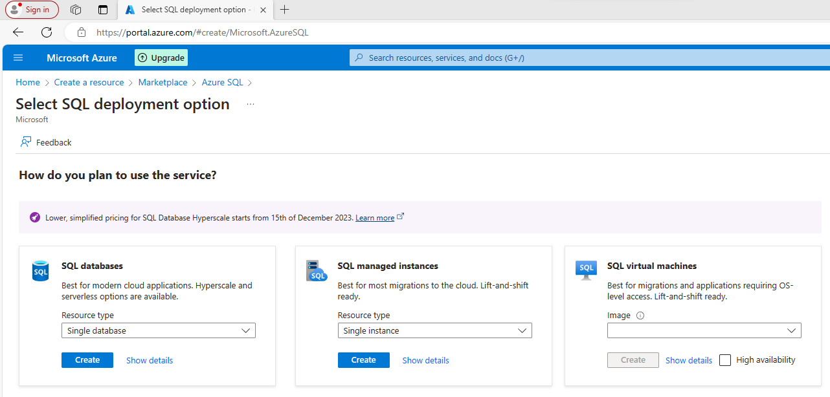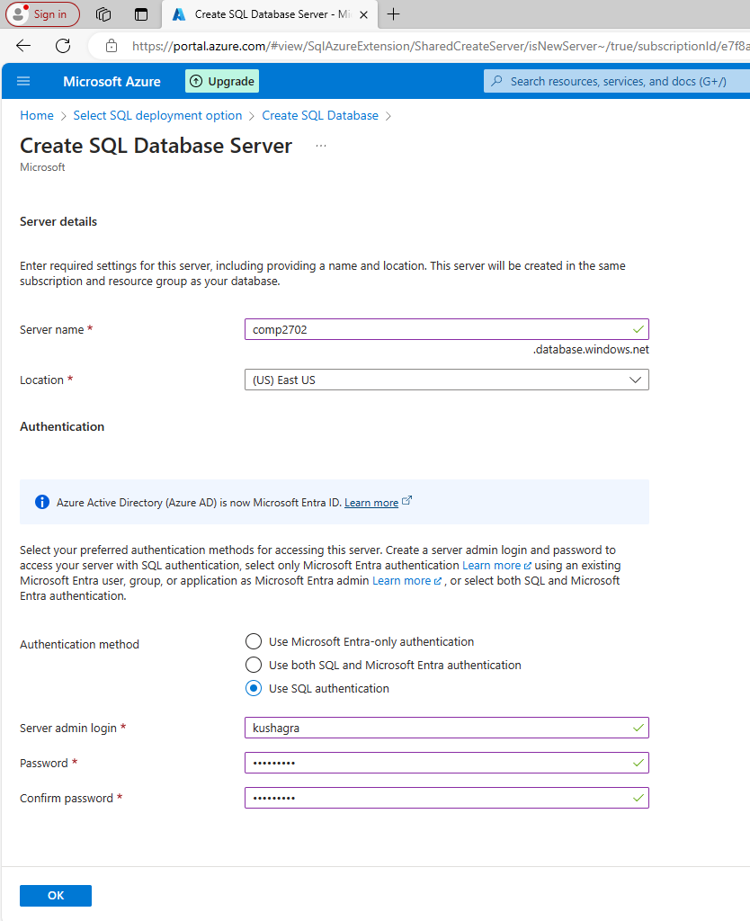

Figure 5: Make sure to keep the ID and the Password Safe. We will need it later.

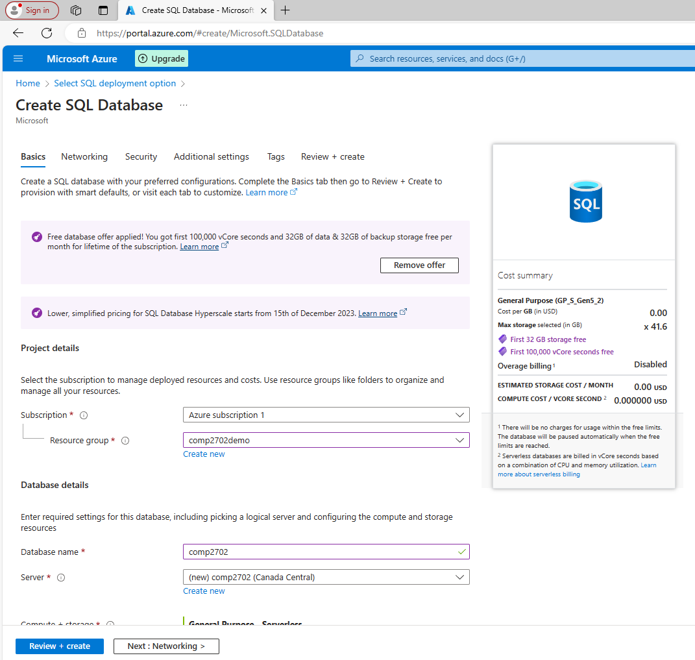

Refer Table 1

For standardized naming convention

Figure 6: Create new resource group if needed. Add a database name and select a server.

Figure 7: Proceed with defaults.

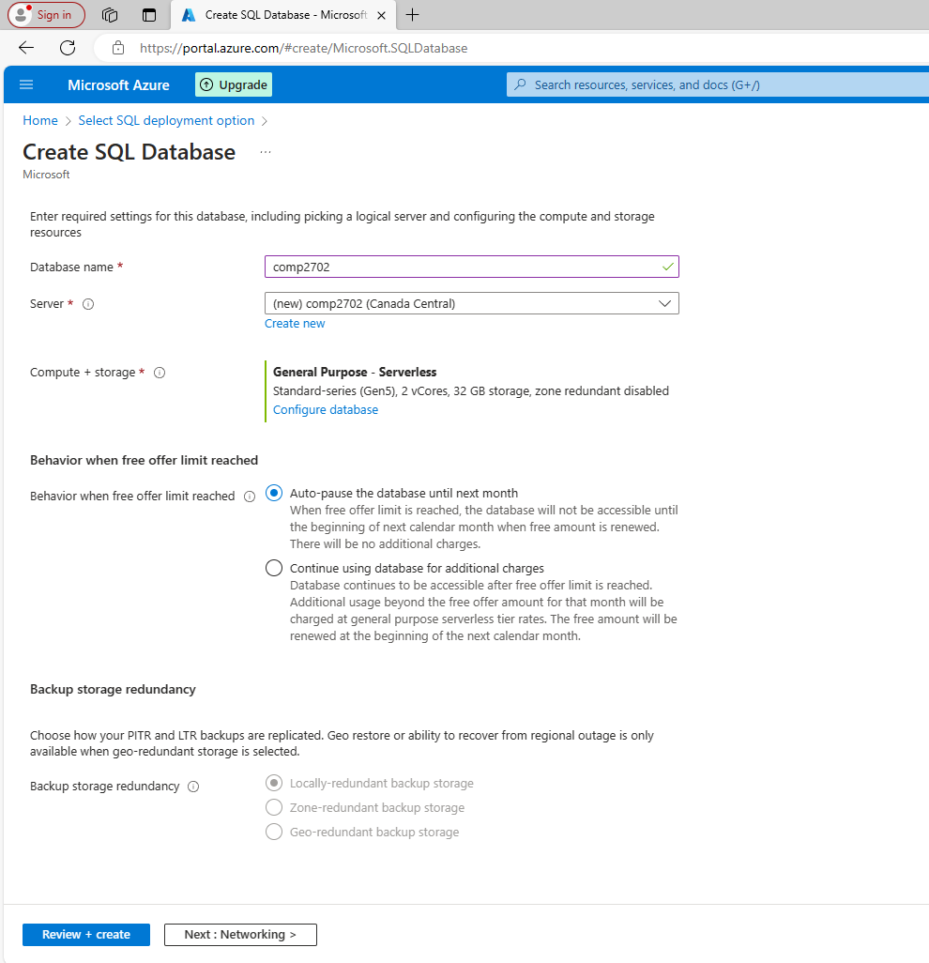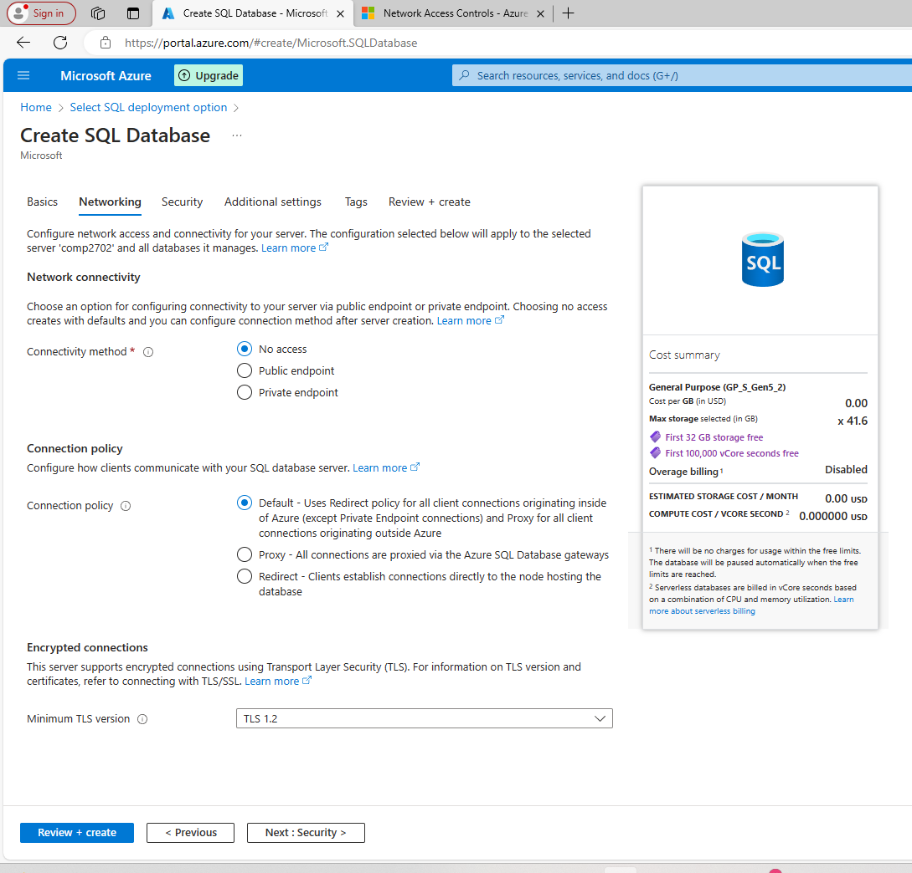

Figure 8: Procced as shown.

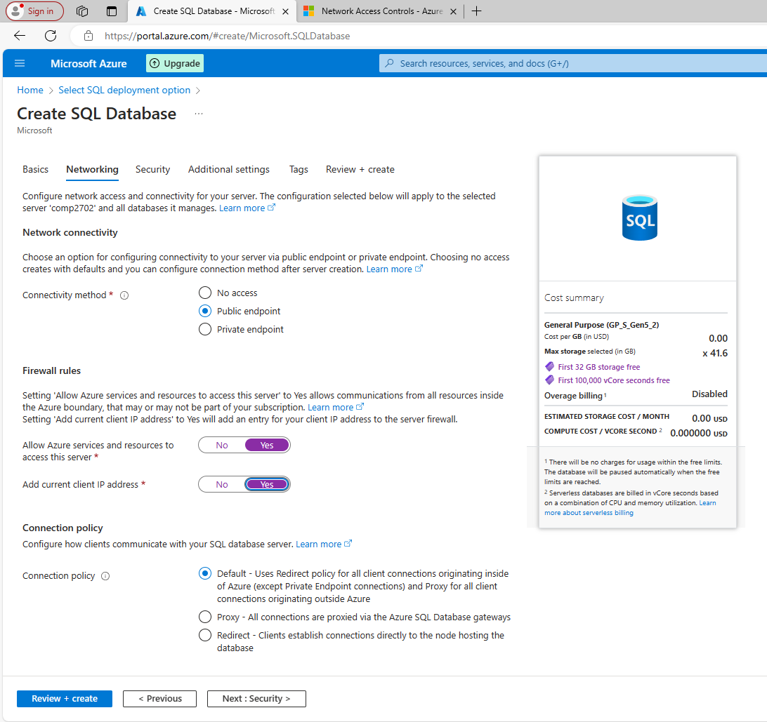

Figure 9: Procced as shown.

Figure 10: Procced as shown.

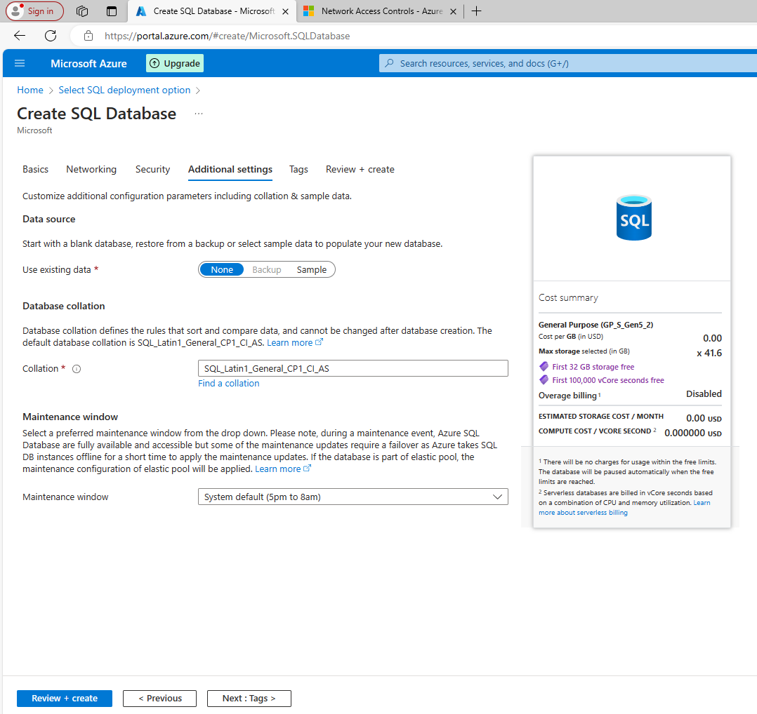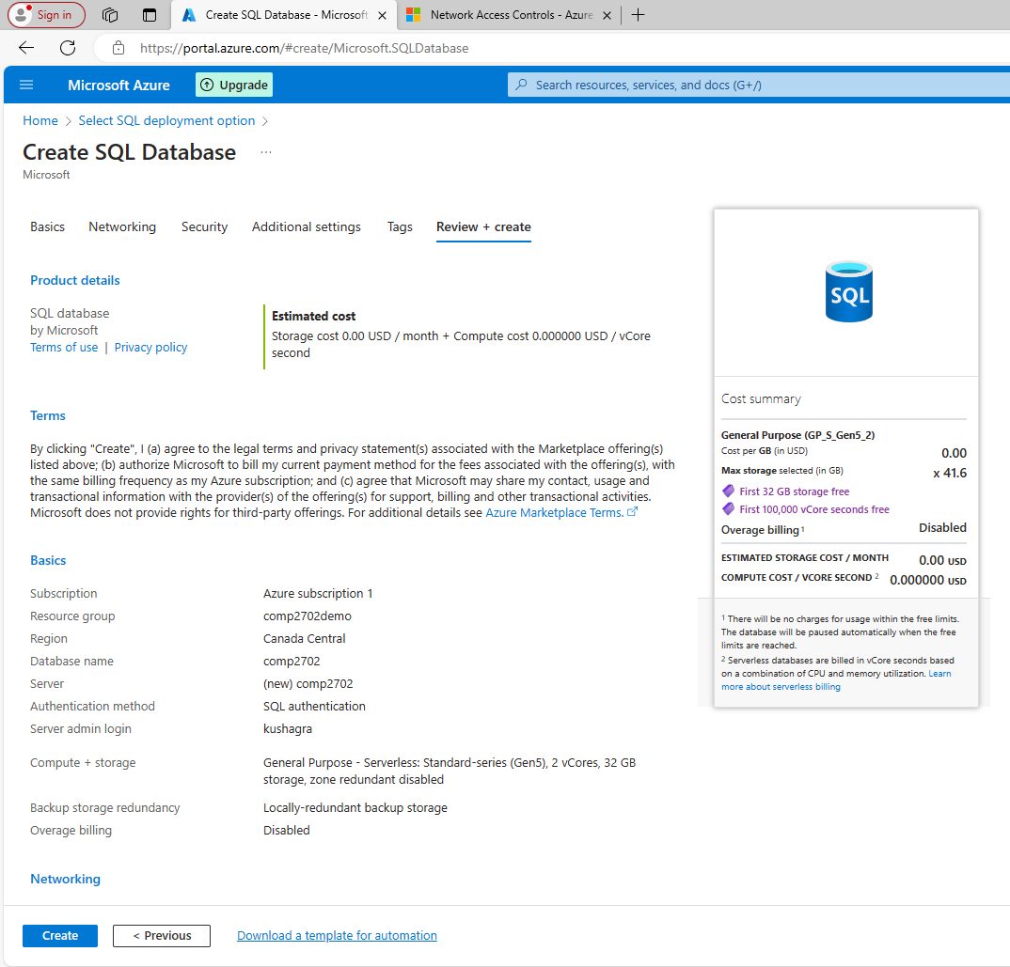

Figure 11: Create the Database and review the costs.

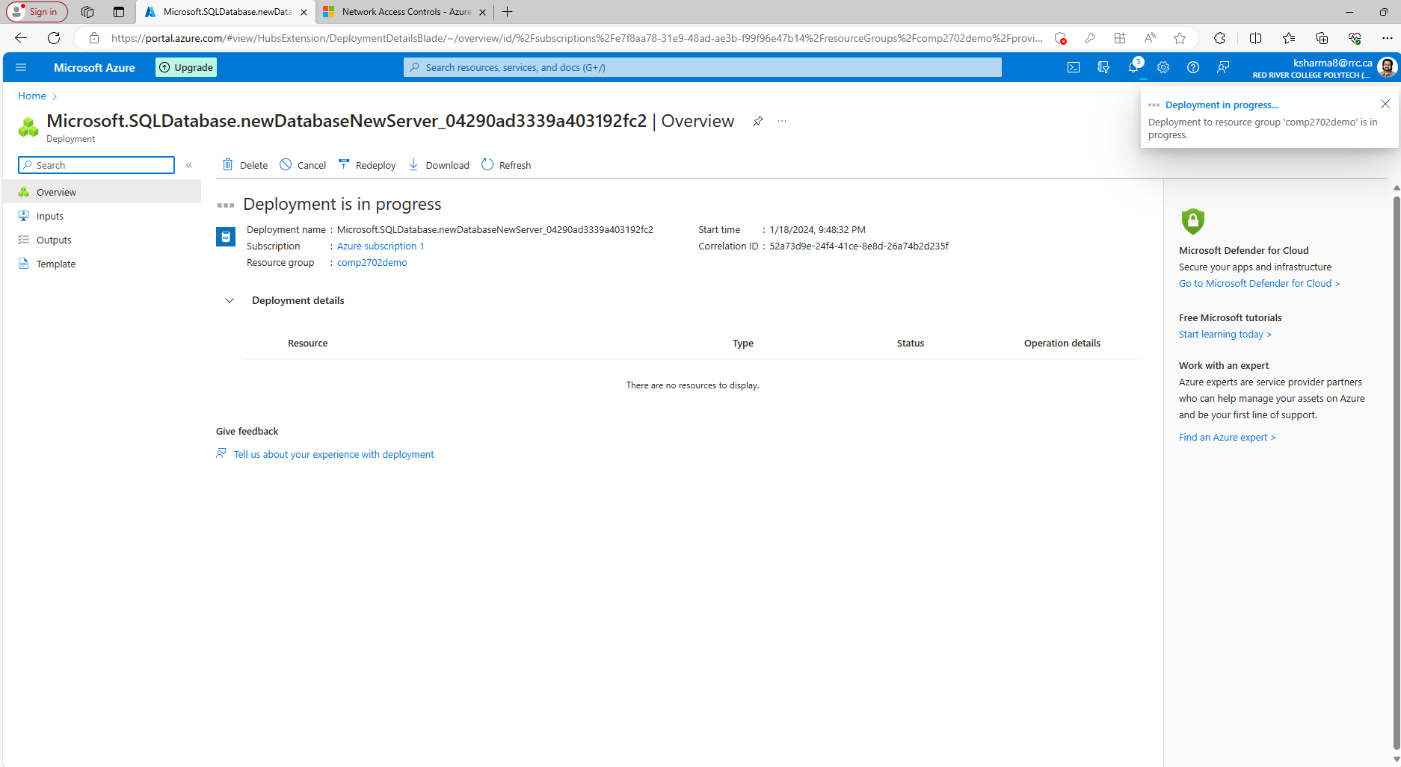

Figure 12: May take 2-5 mins to deploy.

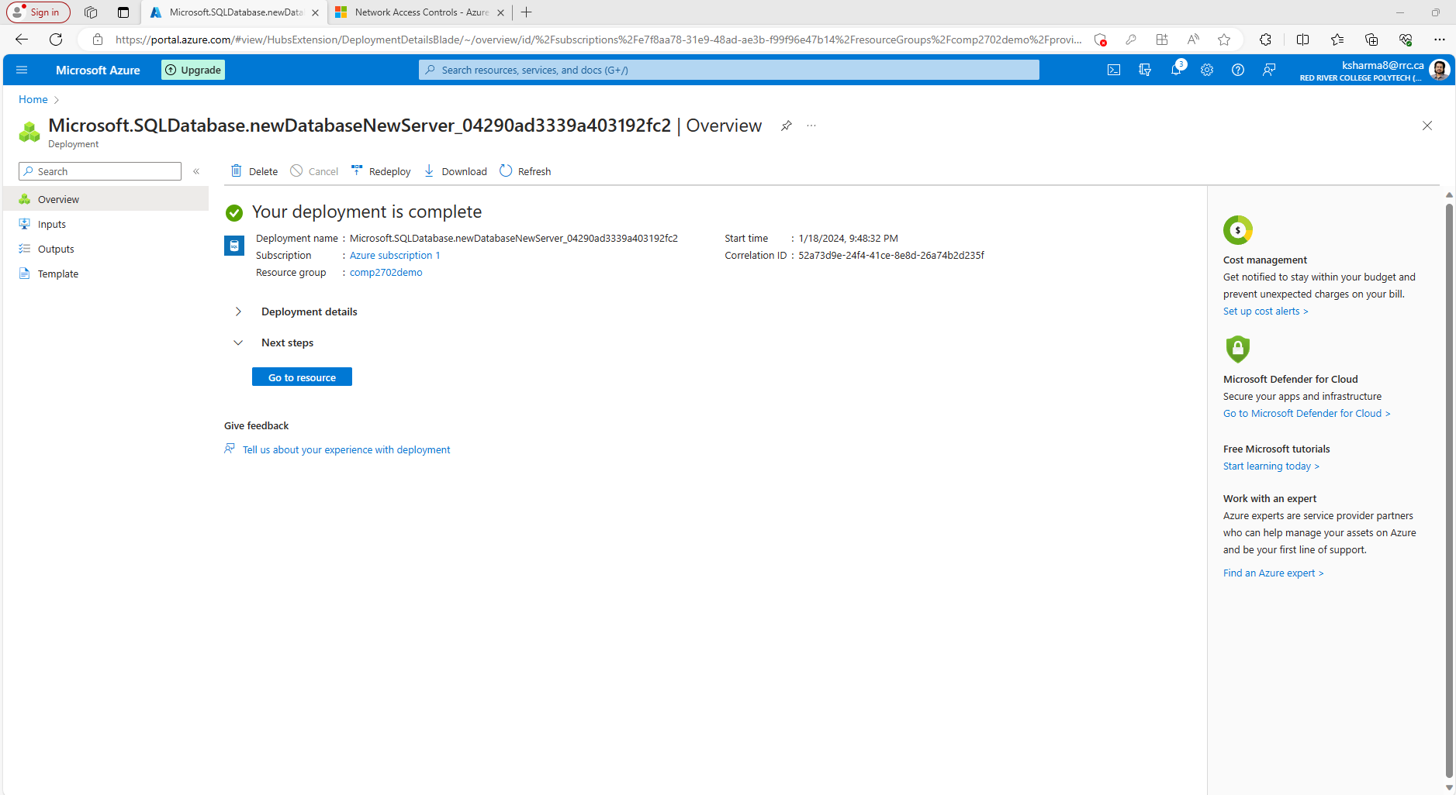

Figure 13: Hurray!! It's ready to be used.

## Connecting to the Azure database using DBeaver

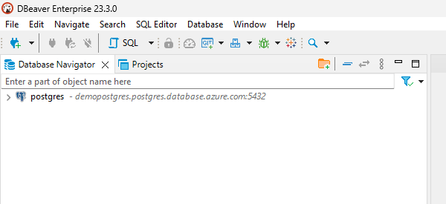

Figure 14: Click on the icon.

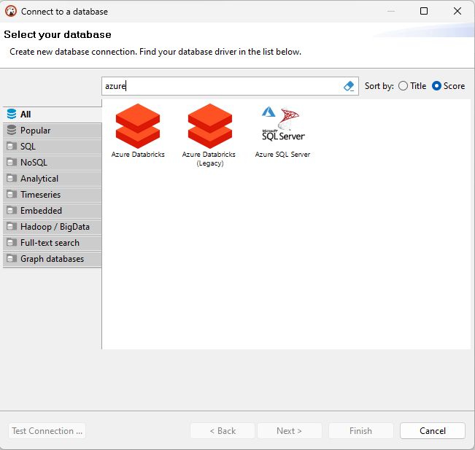

Figure 15: select Azure SQL Server.

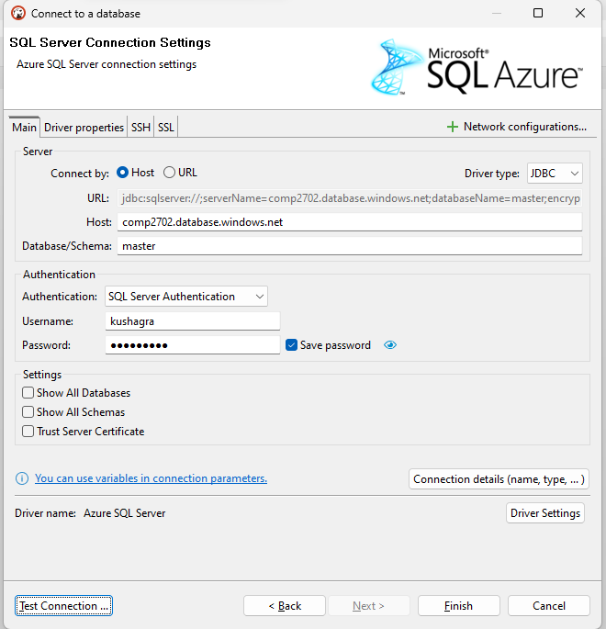

Figure 16: Fill in the details as in overview section of your SQL server. Refer Figure 17 for more details.

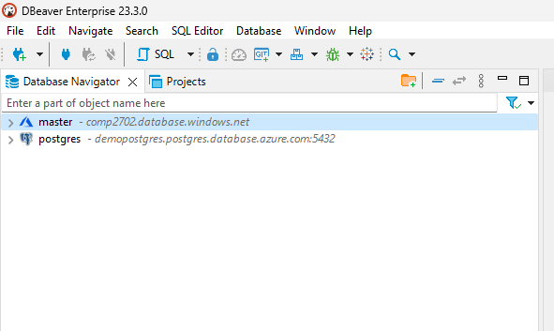

Figure 17: Azure SQL server added successfully and is ready for use.

## Connecting Azure database to Microsoft SQL Server Management Studio

For installing Microsoft SQL Server Management Studio refer **Annexure II (b)**.

Go to your Database overview and grab the server name.

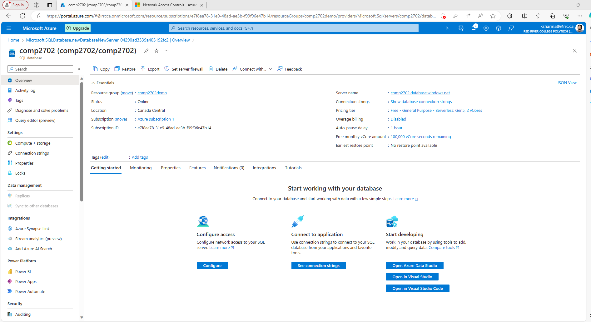

Figure 18: From Dashboard, go to azure SQL and you’ll find it there by clicking on the database your just created. Take a note of the server’s name.

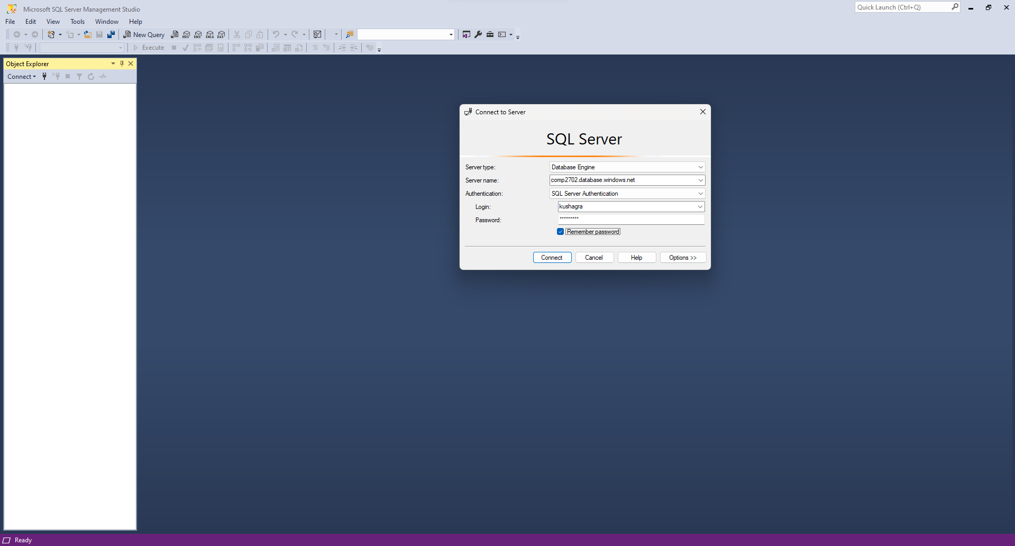

Figure 19: Type the Username and the password for the Database.

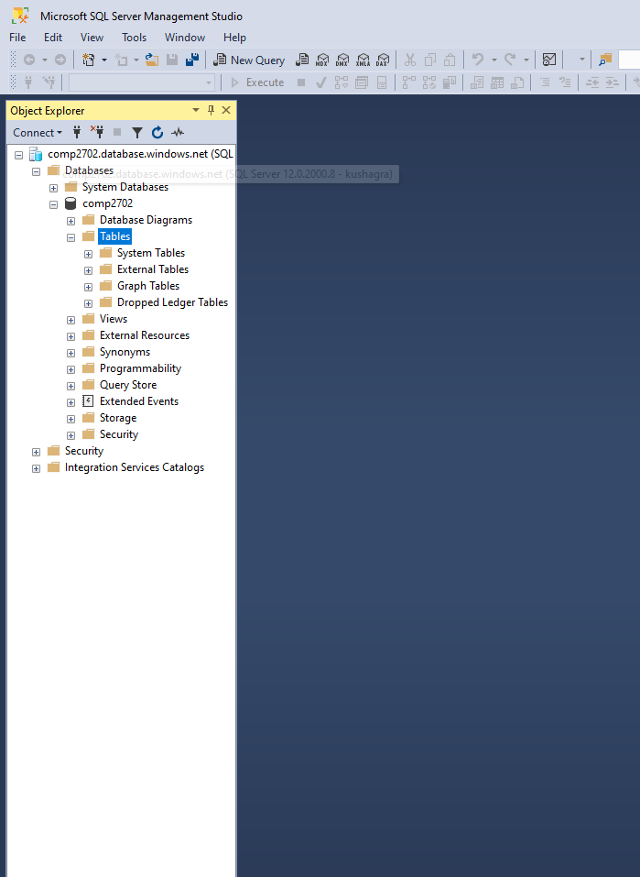

Figure 20: Explore the database with the explorer.

## Connecting to the deployed AzureSQL database via Azure Portal

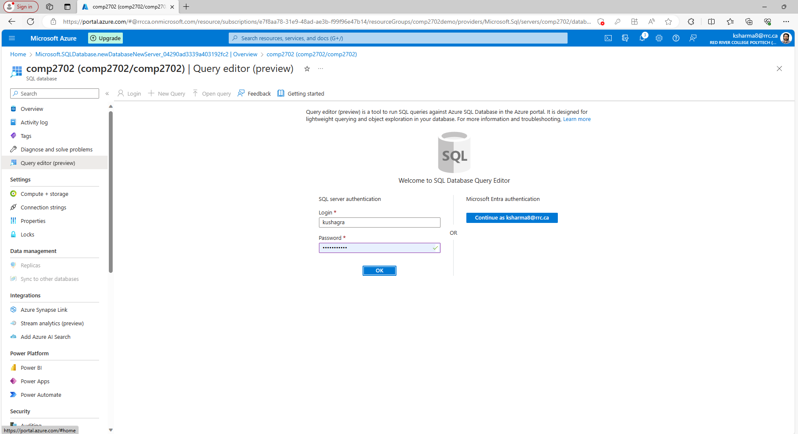

Figure 21: Select your database from the Azure SQL portal, go to Query Editor and enter your User ID and Password to connect.

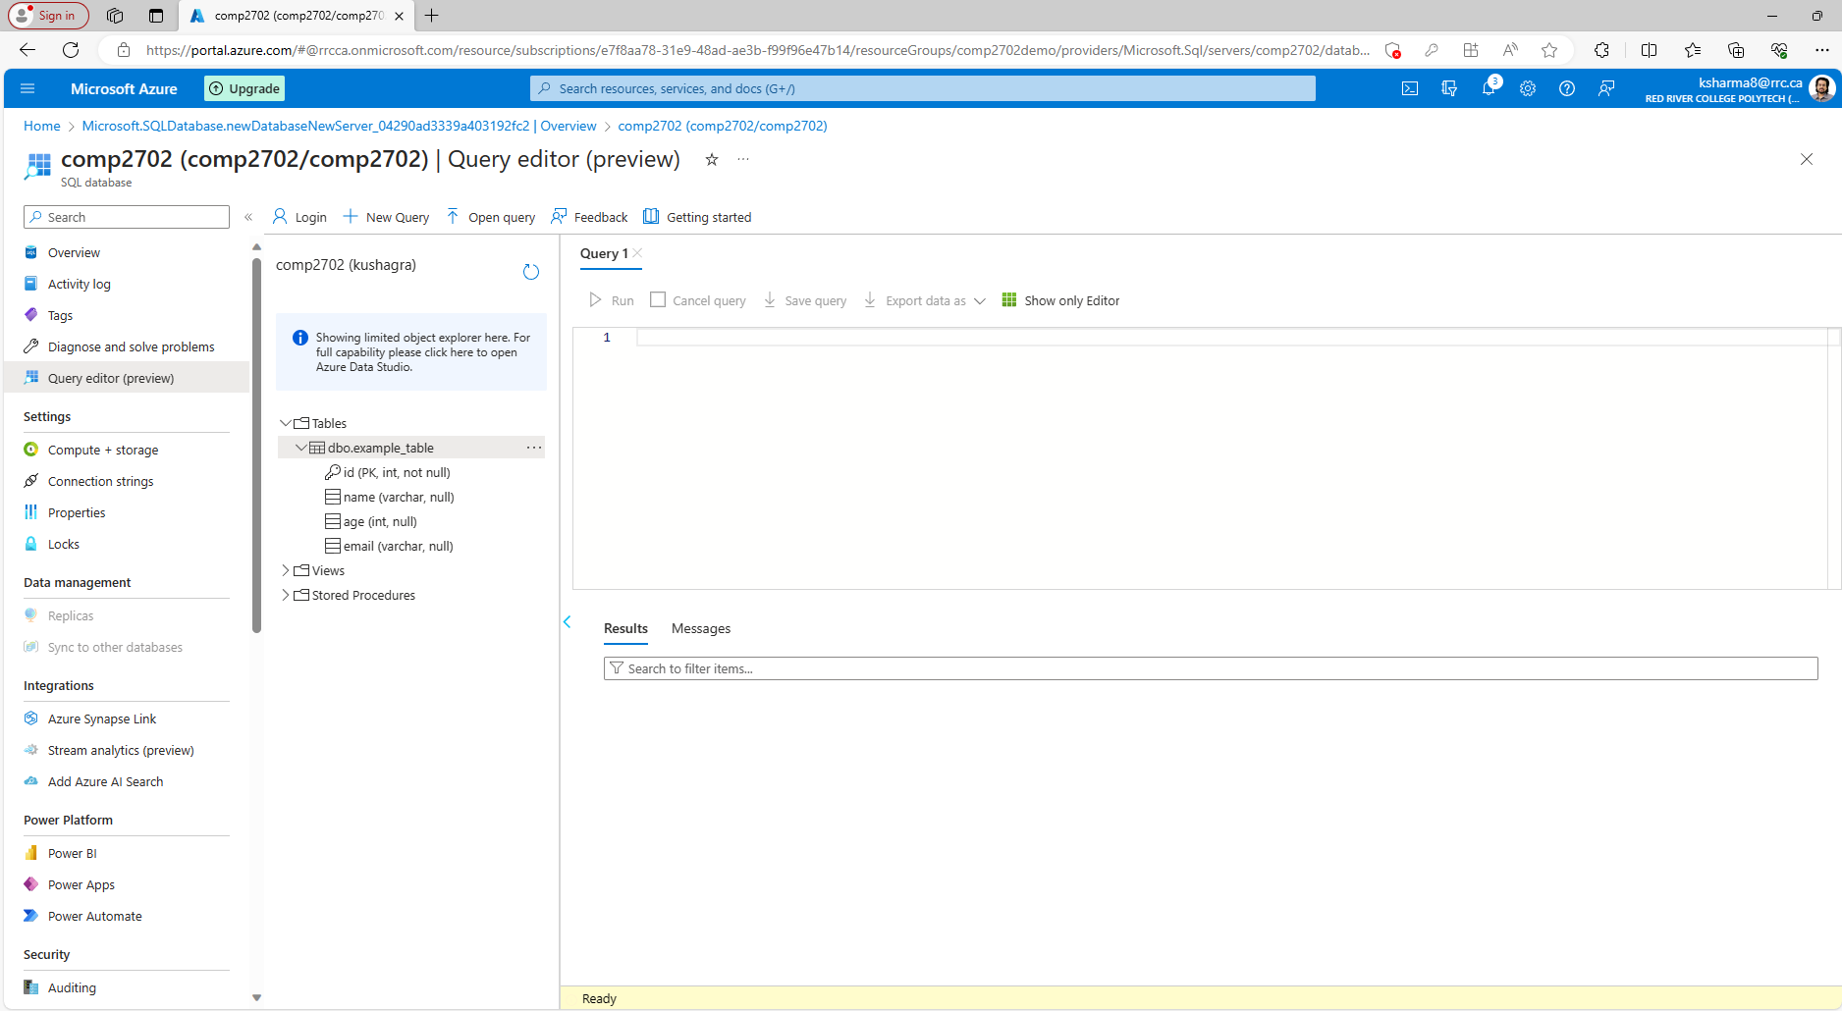

Figure 22: Find your tables and run the queries.

## Hands-on Database Exercises

## Please don’t forget to pause/delete/terminate the service when you are done

If you don’t want to get billed unnecessarily, immediately stop the services when not in use.

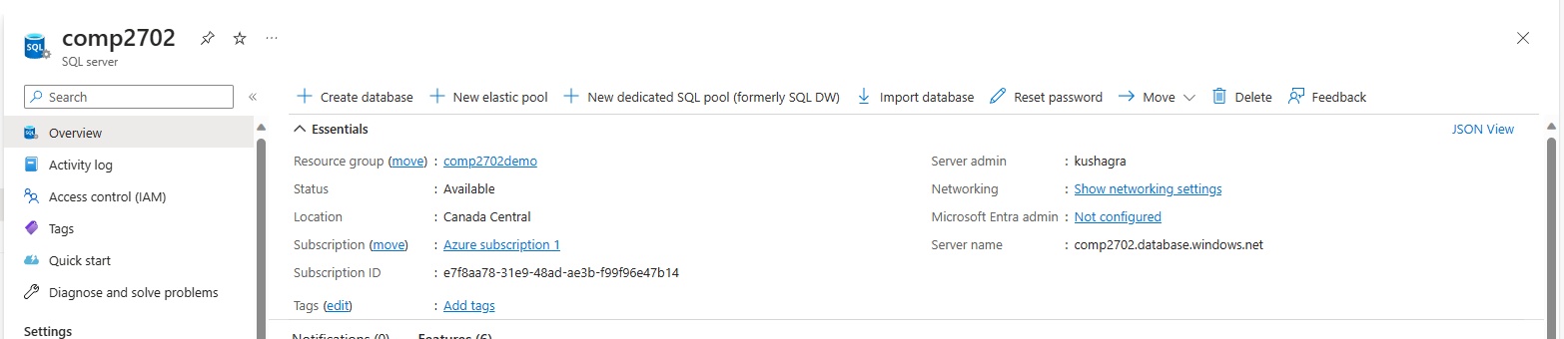

Figure 23: Find the delete button in the overview section.

# **Provisioning and Deploying Azure MYSQL flexible**

Azure MySQL Flexible Server is a deployment option within Azure Database for MySQL, offering users enhanced customization and control over server configurations. It allows users to choose specific MySQL versions, scale resources dynamically, and configure parameters tailored to their application needs. With features such as automated backups, high availability options, and robust security measures, it provides flexibility and reliability for managing MySQL databases in the Azure cloud.

Agenda:

* To create a database using Azure SQL.
* Connecting to the database using MySQL Workbench
* Connecting to the using Azure bash
* Perform Operations on the Database

Future: Integration with analytics software such as PowerBI or Tableau.

## Creating an Azure MySQL database

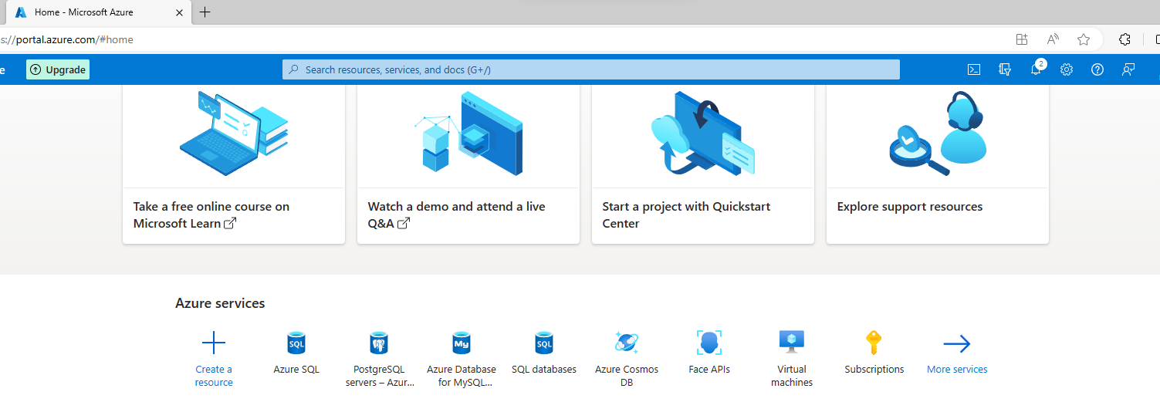

Figure 24: Click on create a resource and search for "azure MySQL server".

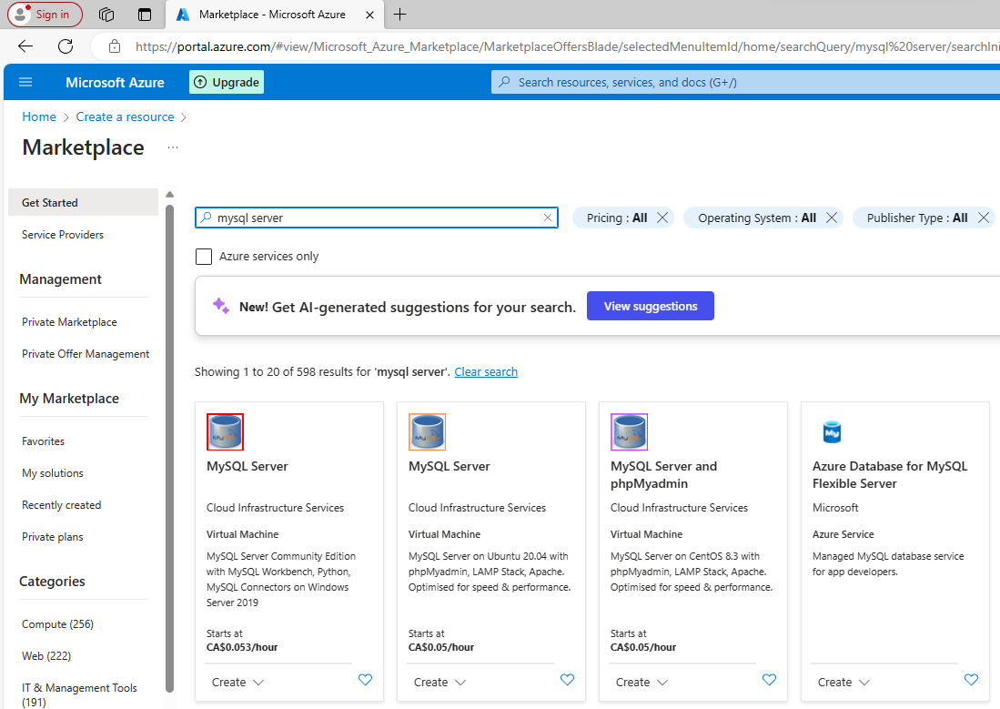

Figure 25: Click on Azure Database for MySQL Flexible Server.

Figure 26: Procced as shown.

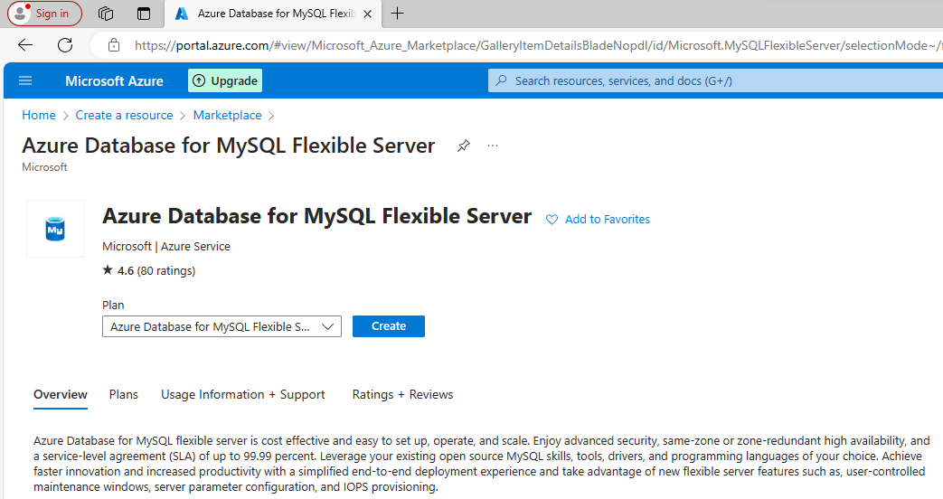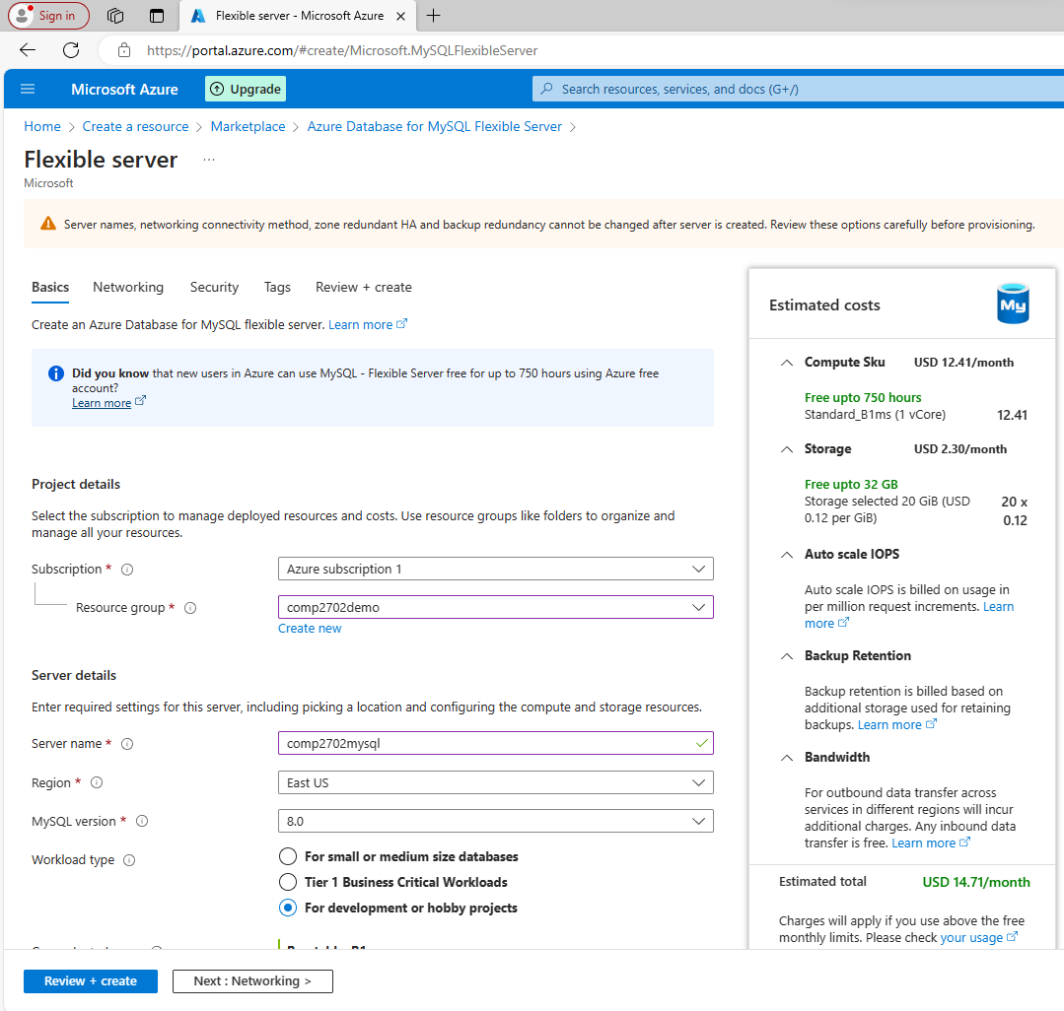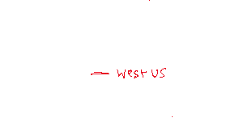

Figure 27: Follow Table 1 for standardization.

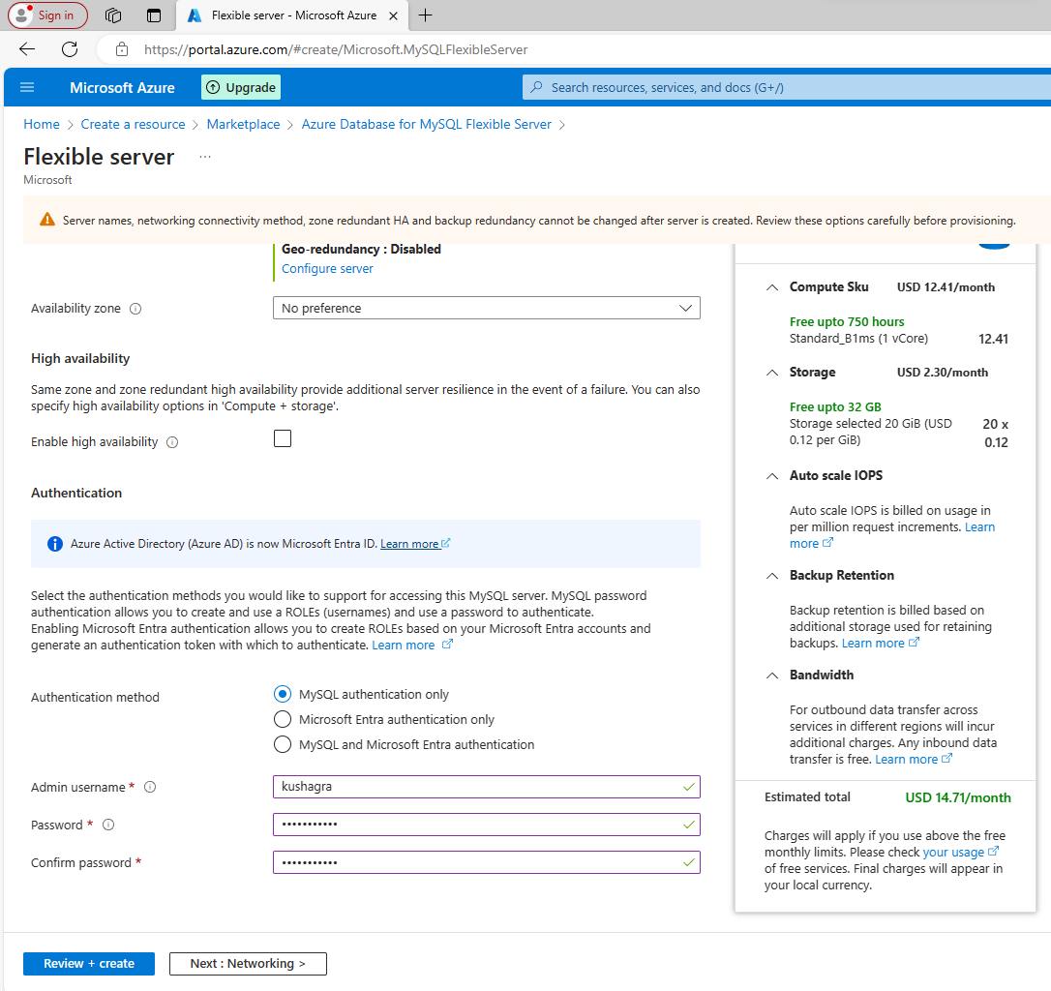

Figure 28: Procced as shown. Make sure to follow Table 1.

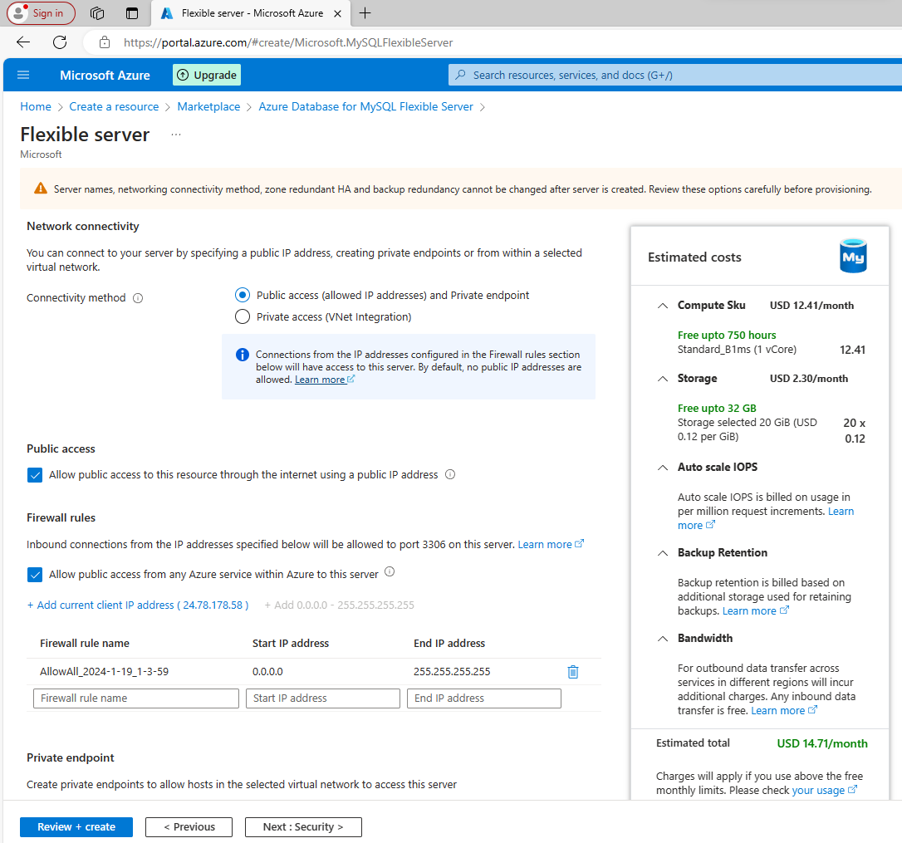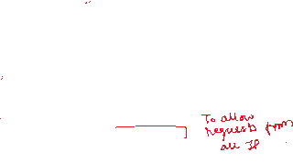

Figure 29: Selecting the shown IP range gives you the ability to access this server from anywhere.

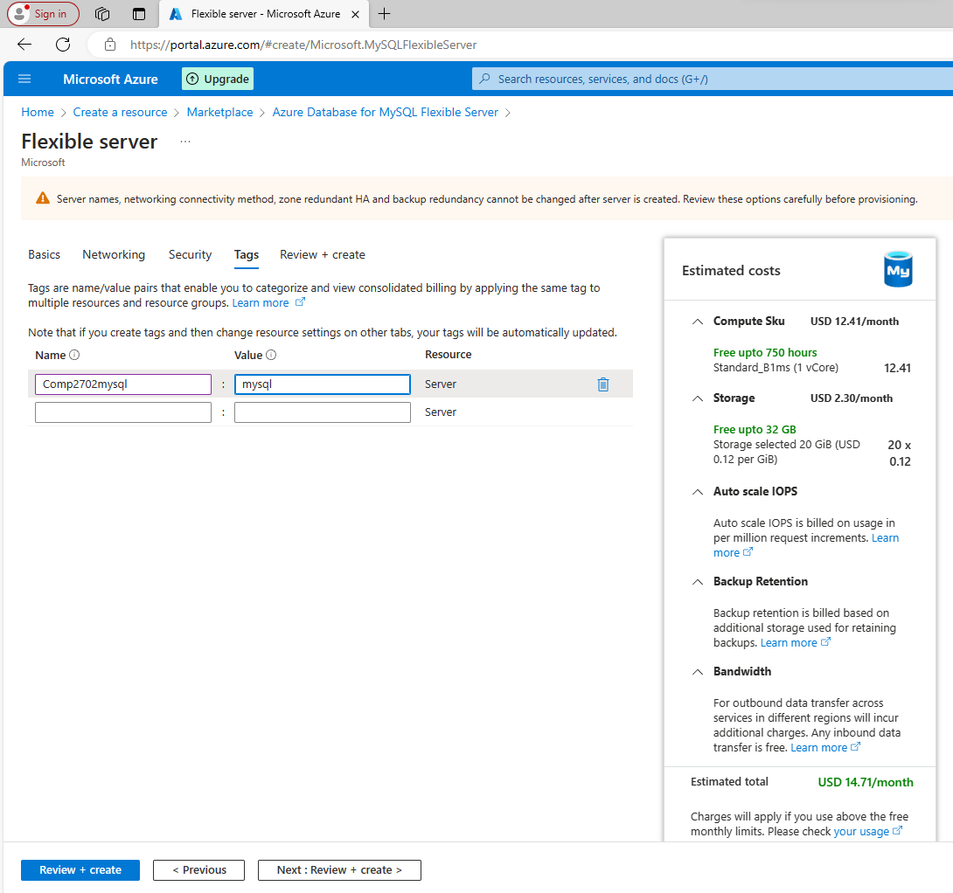

Figure 30: Use Table 1 for standardization.

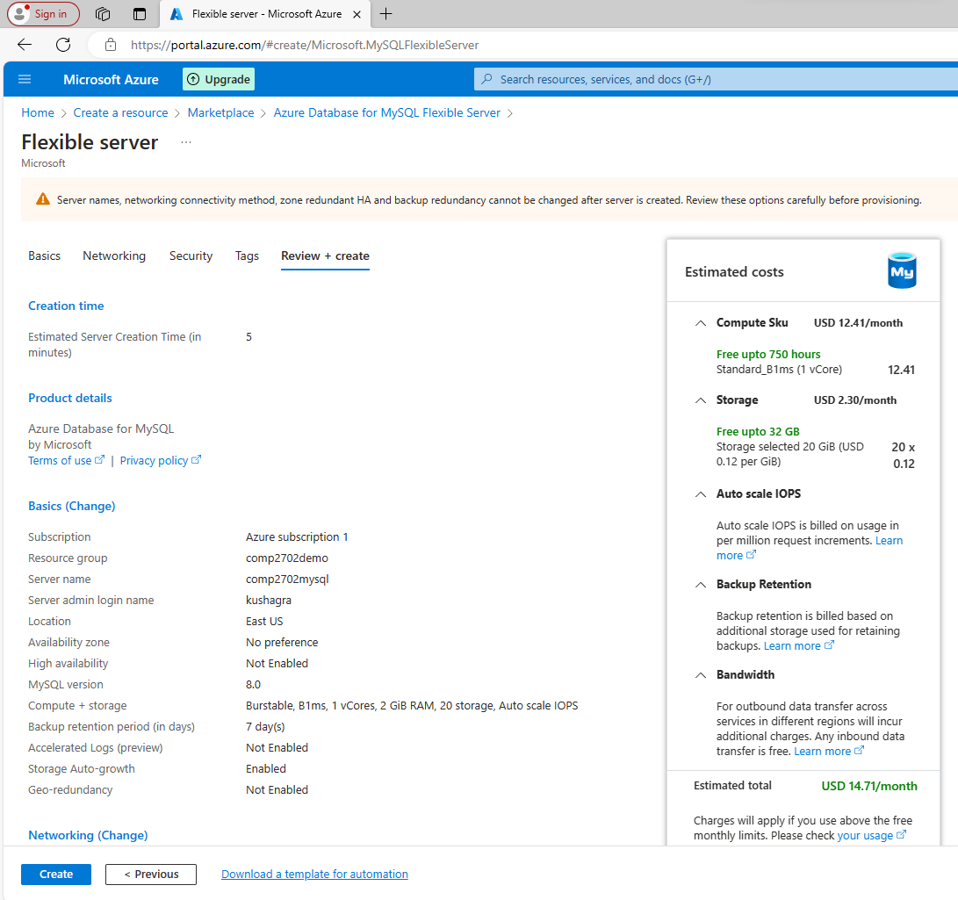

Figure 31: Make sure everything is as expected. Review the costs and click create.

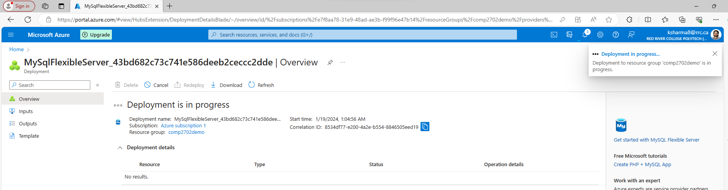

Figure 32: It may take 5-10 minutes to get deployed. Please be patient.

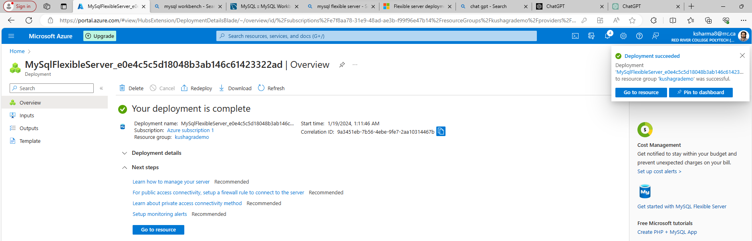

Figure 33: Once deployed, you can open the resource panel or proceed to the next section.

## Connecting to the database using DBeaver

Go to:   
Resource > Overview

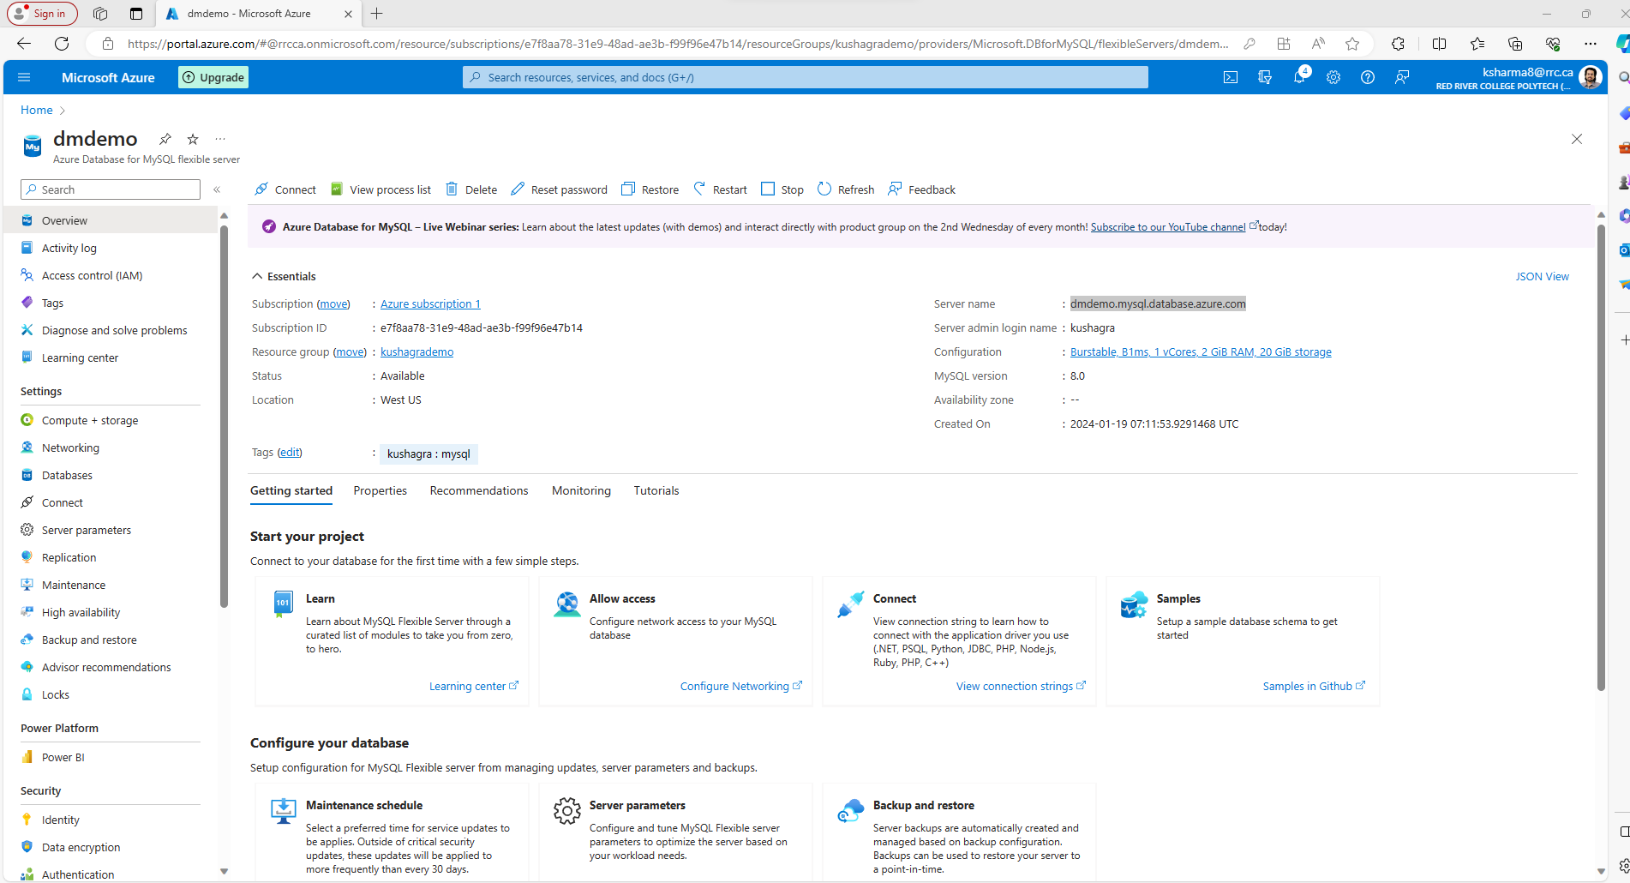

Figure 34: Copy the server's name.

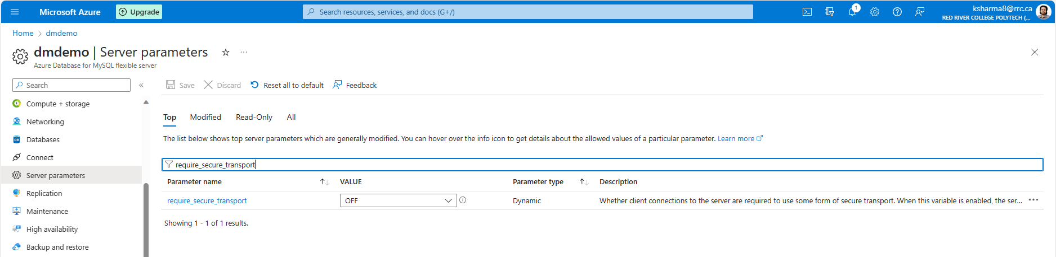

Figure 35: require_secure_transport is ON by default. For DBeaver, turn it off.

Figure 36: Select MySQL

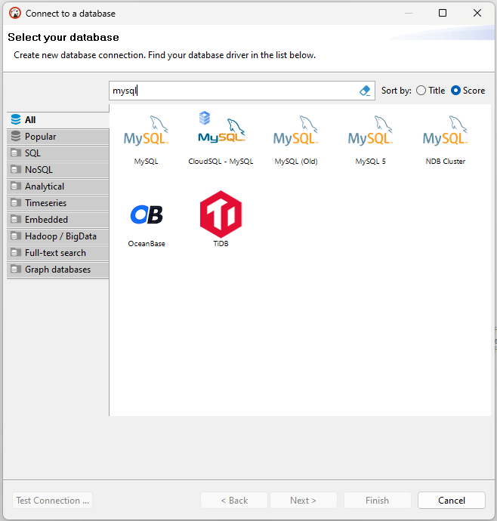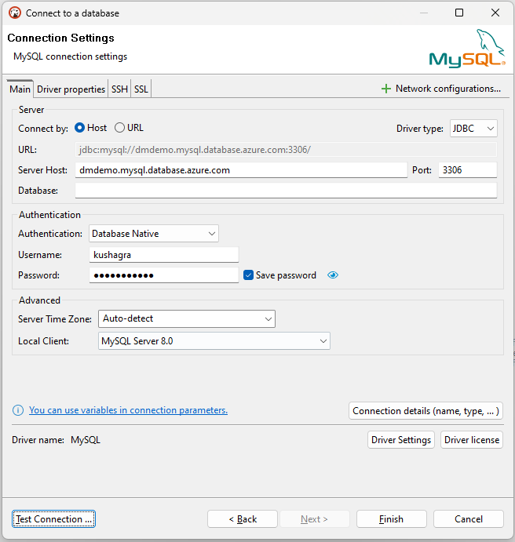

Figure 37: Fill in the details as needed and test the connection. Upon successful test, click Finish to add the server.

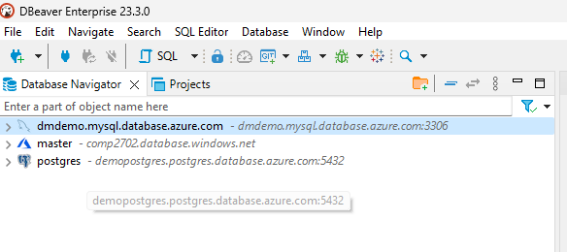

Figure 38: Server has been added and is ready for use.

## Connecting to the database with MySQL Workbench

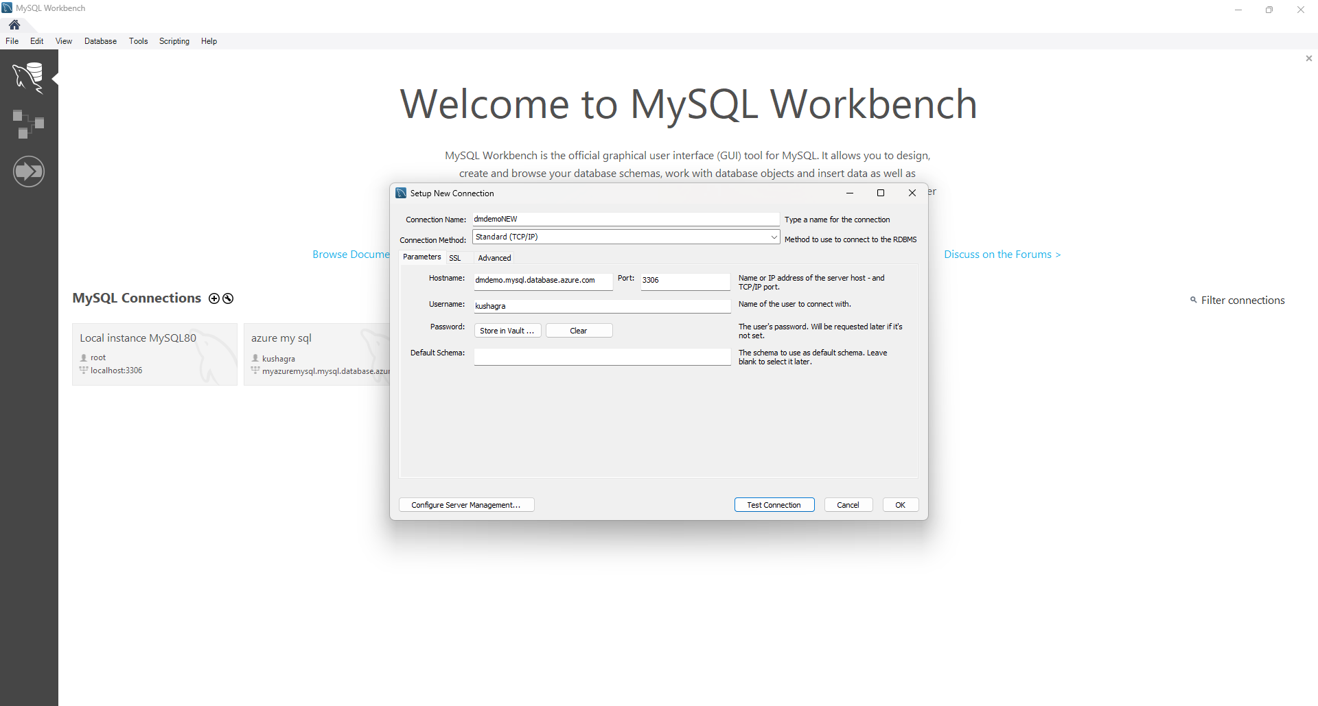

Figure 39: Enter the server’s name and your username. Hit Test Connection. Enter the password and save it to the vault.

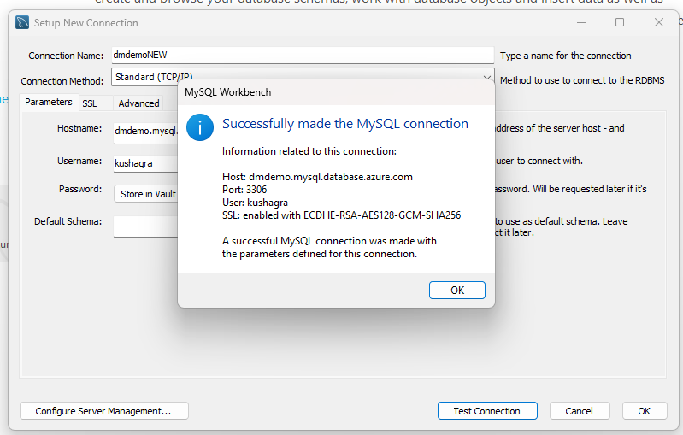

Figure 40: A successful test means you are able to communicate with the Azure cloud.

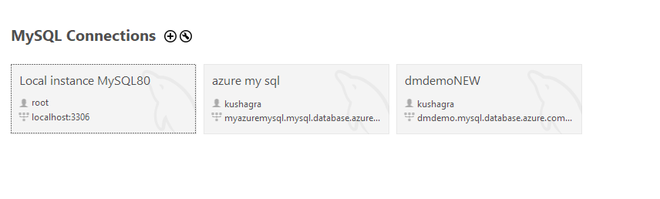

Figure 41: Connect to the database.

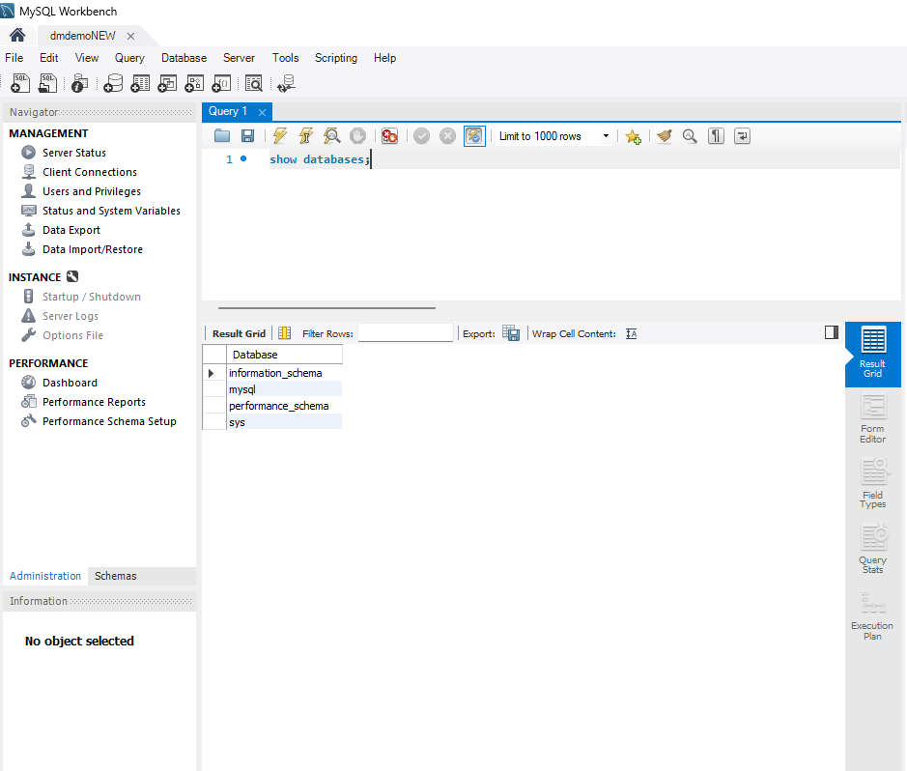

Figure 42: Database is ready for use. Yayy!!

## Connecting to the database with integrated Azure Bash Shell



Figure 43: Notice the connect, stop, reset and resume buttons. Click on connect.

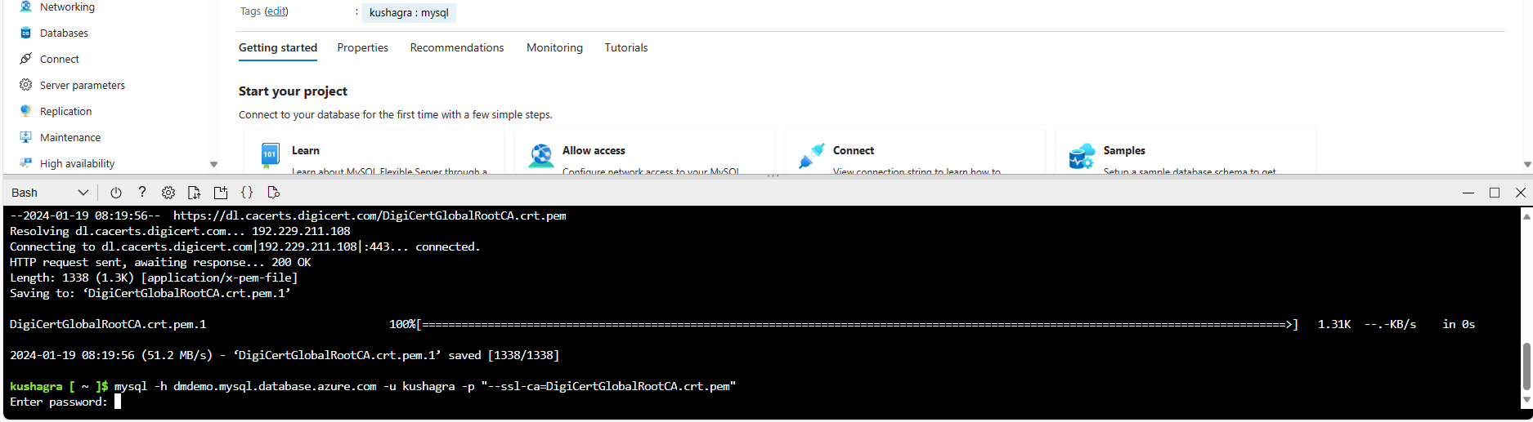

Figure 44: A window pops up from the bottom and asks for password.

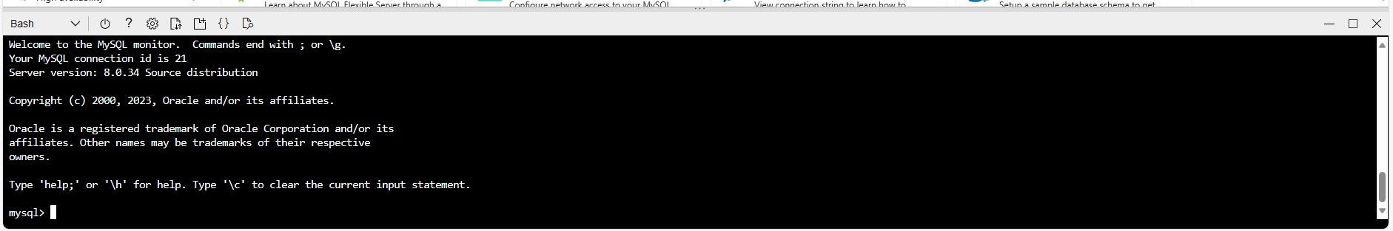

Figure 45: After entering the password we have access to the MySQL shell.

## Hands-on Database Exercise

# **Provisioning and Deploying Azure Database for PostgreSQL**

## Setting up PostgreSQL Database

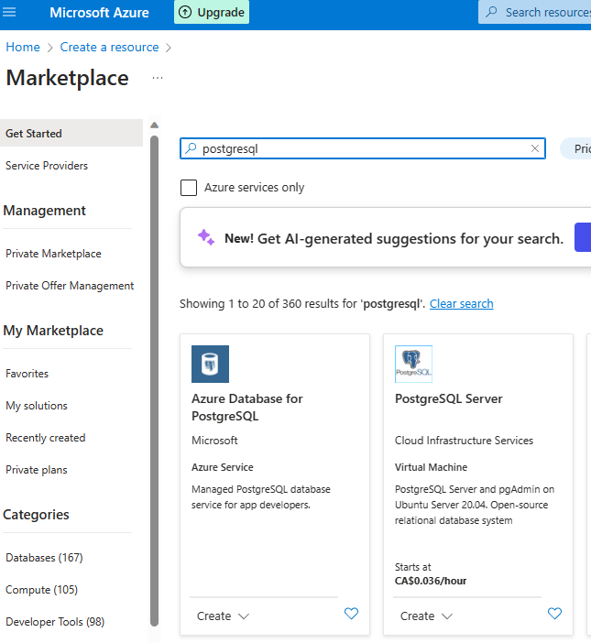

Figure 46: Seach for PostgreSQL and select the option shown.

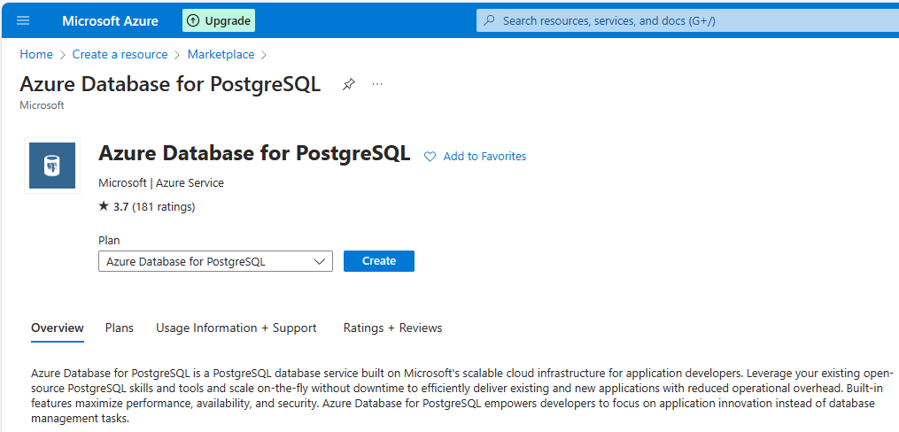

Figure 47: Select as shown and click on create.

Refer Table 1

For standardized naming convention

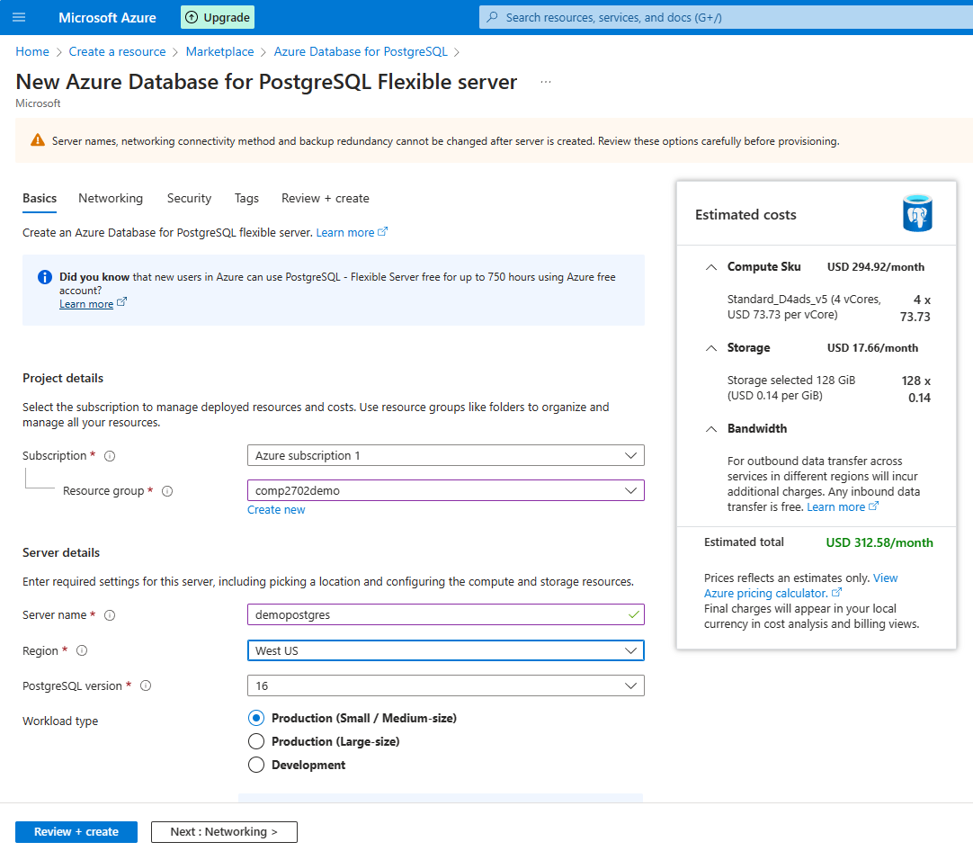

Figure 48: Fill up the required fields as per the naming convention and review the costs.

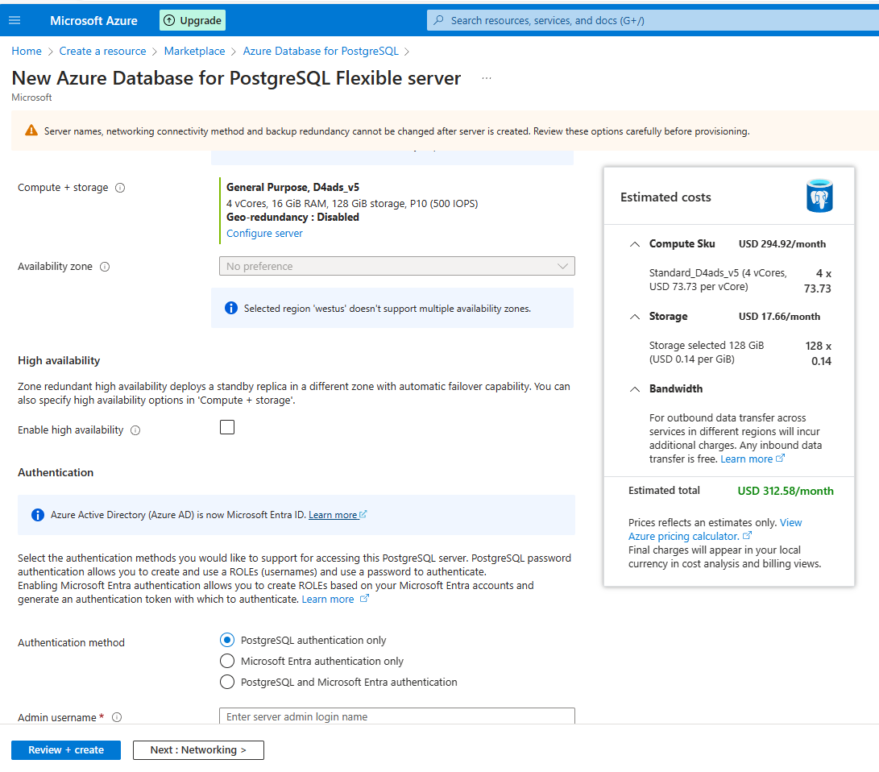

Figure 49: Change the server configuration to burstable.

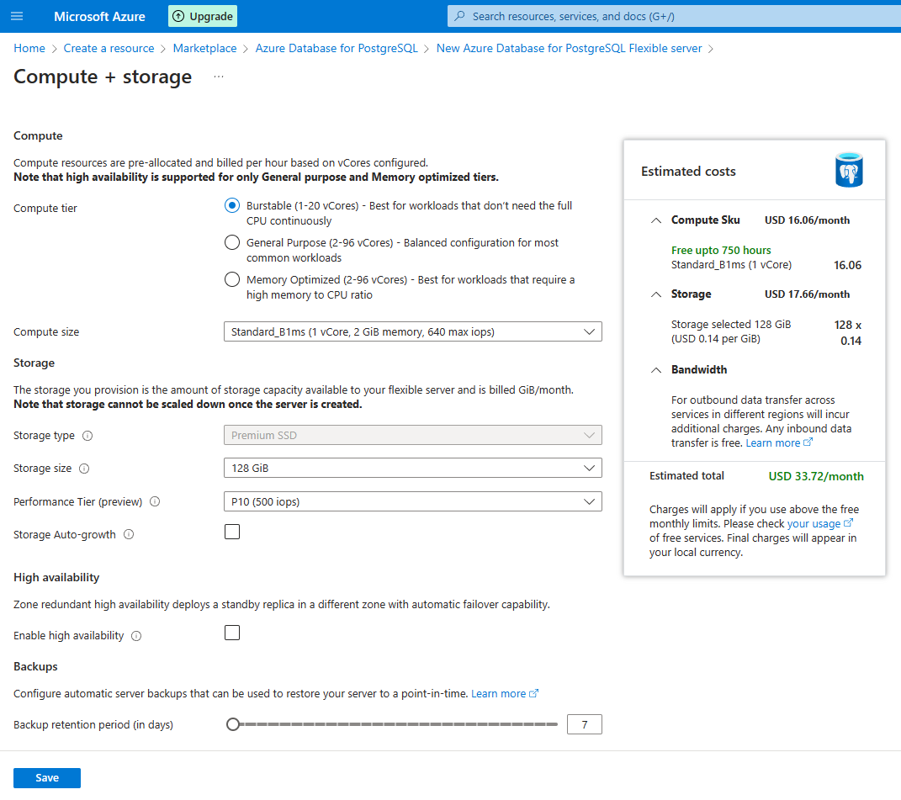

Figure 50: Select as shown and review the cost. Make sure to tick Storage auto-growth.

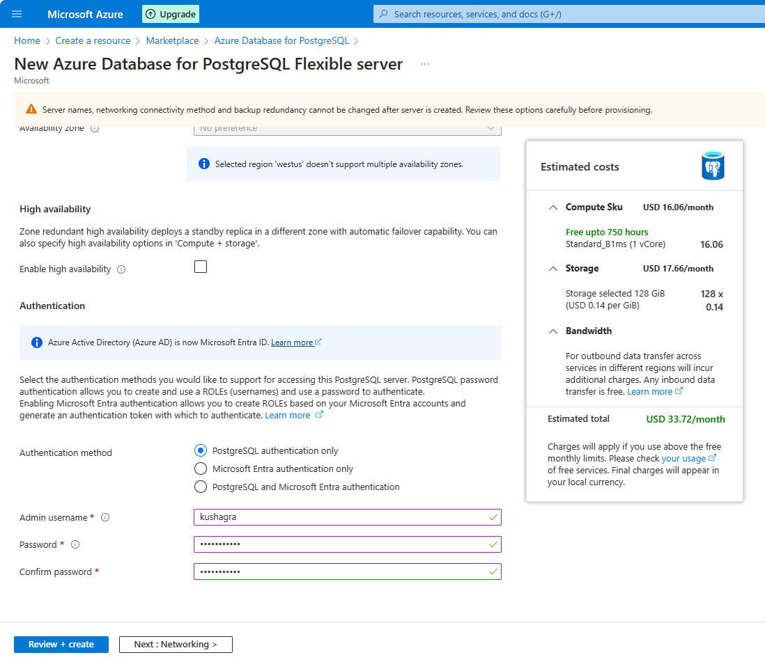

v

Figure 51: Keep the ID and the Password safe.

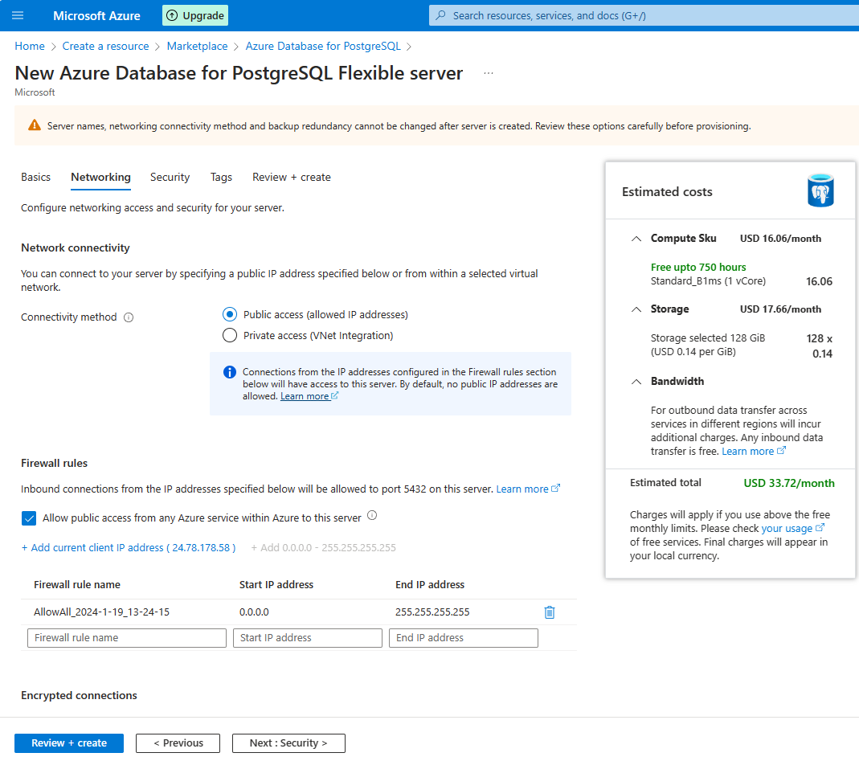

Figure 52: Select the full IP range to allow access from any IP address.

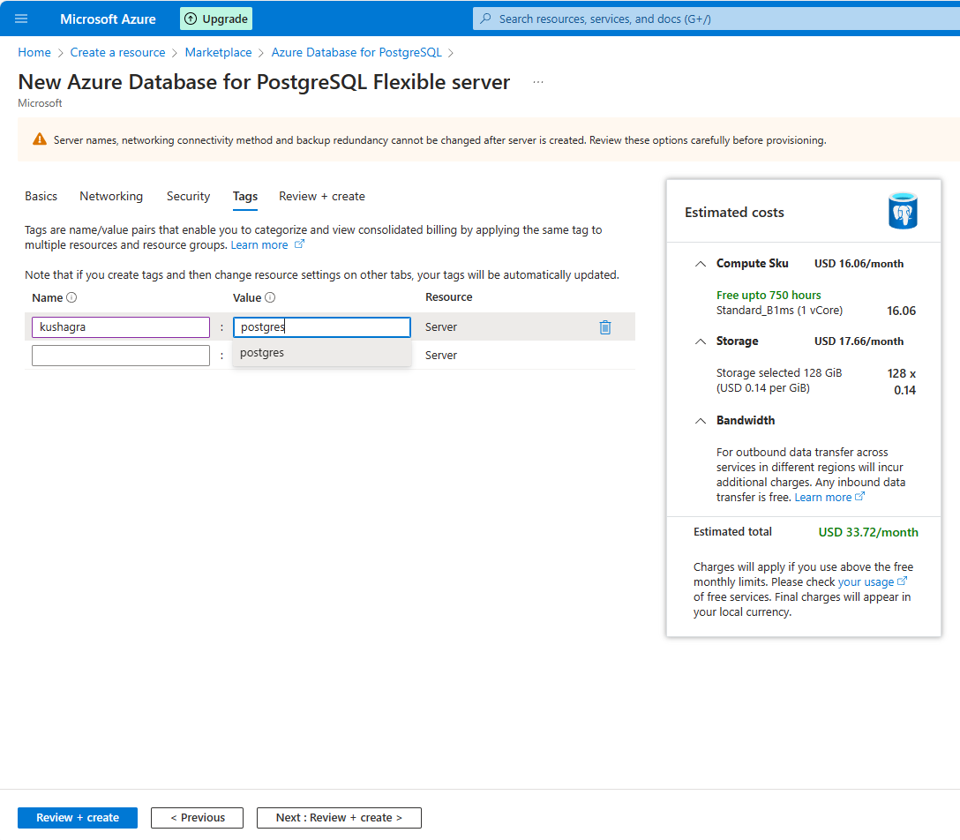

Figure 53: use names as per Table 1.

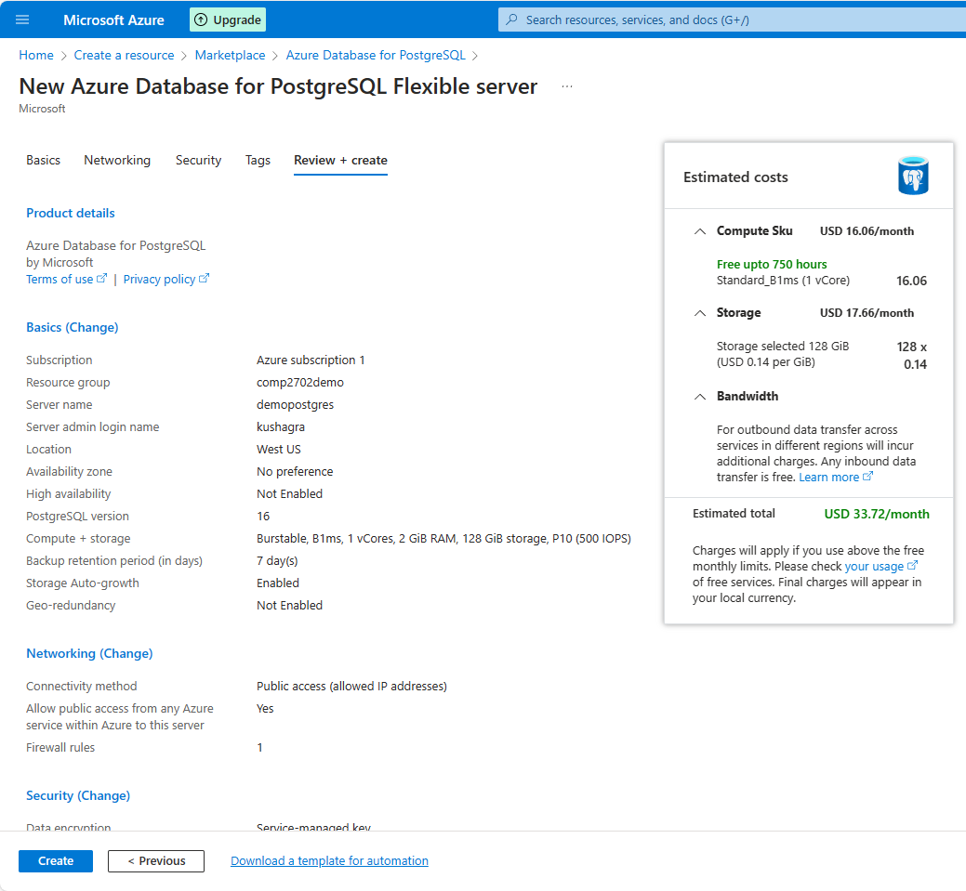

Figure 54: Review the configuration, cost and create.

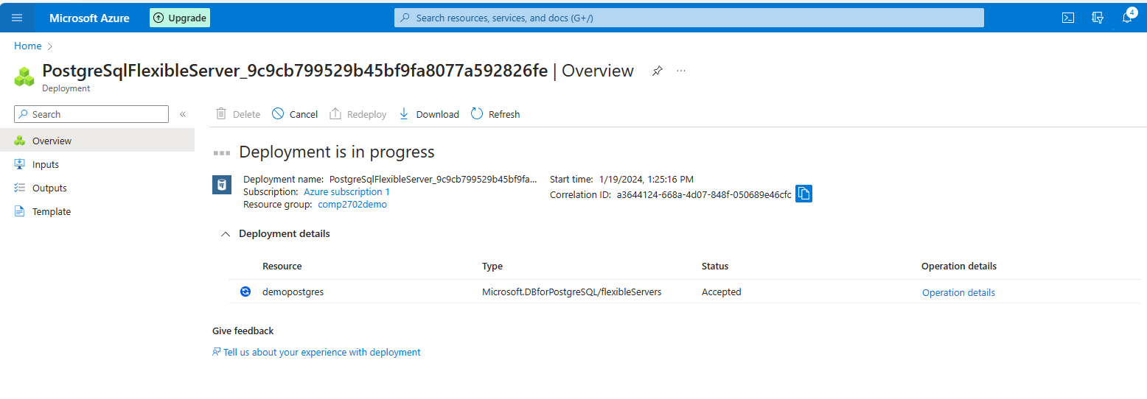

Figure 55: May take longer to deploy. Please wait for 10 minutes or error status.

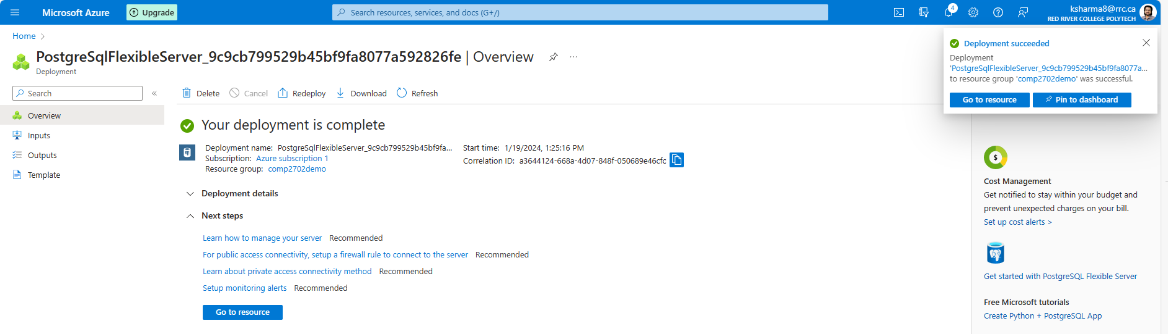

Figure 56: Yayy!! It is ready for use...

## Connecting to the deployed PostgreSQL database using DBeaver

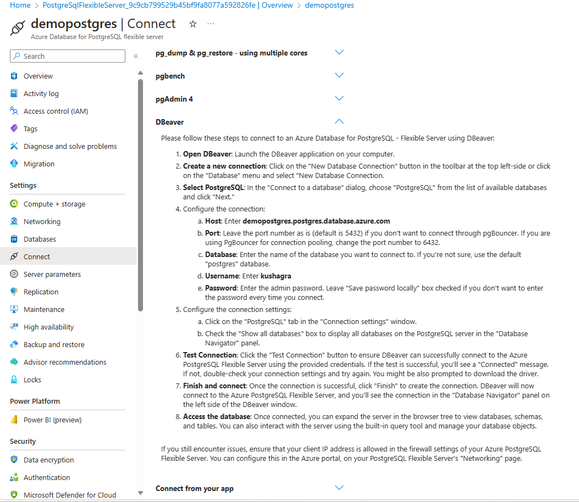

Figure 57: Find the instruction manual in your resource management panel.

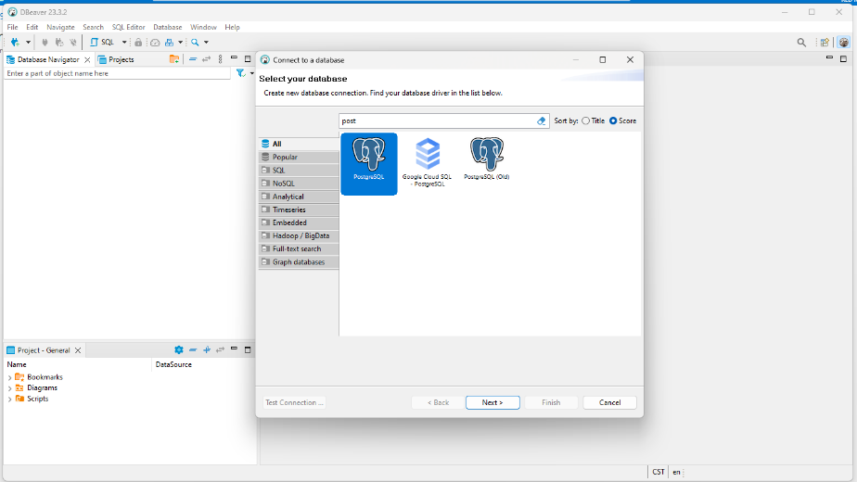

Figure 58: Add a connection, search for PostgreSQL and click on next.

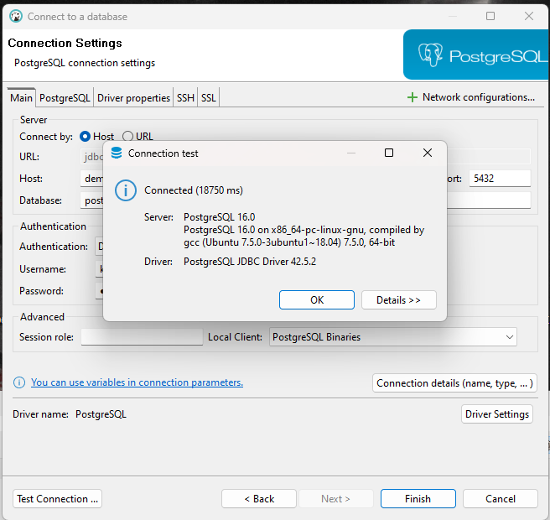

Figure 59: Fill in the required details, test the connection and Finish. PostgreSQL is ready for use.

## Hands-on Database Exercise

# Implementing a No SQL Databases in Azure– Cosmos DB

## No SQL DATABASES

Objective:

* High level overview of NOSQL or Non-Relational Databases
* Implementing Azure Cosmos DB
* High Level overview of how Non-Relational Database can be created
* Implement a lab to create a nosql database and add some data via Visual Studio Code

What is not covered:

* For simplicity, we will transfer images, pdf files or any form of data as an attachment.

A NoSQL database always has a structured SQL like component.

A NoSQL (Not Only SQL) database is a type of database that provides a mechanism for storage and retrieval of data that is modeled in ways other than the traditional tabular relational database management system (RDBMS). NoSQL databases are designed to handle large volumes of unstructured, semi-structured, or structured data, and they offer a more flexible data model than traditional relational databases.

Key characteristics of NoSQL databases include:

* **Schema flexibility:** NoSQL databases allow for dynamic and flexible schemas, allowing you to add or remove fields without the need for a predefined schema. This flexibility is particularly useful in scenarios where the data structure evolves rapidly.
* **Scalability:** NoSQL databases are generally designed to scale horizontally, meaning you can add more servers to your NoSQL database to handle increased load. This makes them suitable for handling large amounts of data and high levels of traffic.
* **High performance:** Many NoSQL databases are optimized for specific use cases, providing high performance for tasks such as read and write operations, especially when dealing with large datasets.
* **Different data models:** NoSQL databases can be categorized into various types based on their data models. Common types include document-oriented databases (like MongoDB), key-value stores (like Redis), column-family stores (like Apache Cassandra), and graph databases (like Neo4j).
* **Distributed architecture:** NoSQL databases are often designed to be distributed across multiple nodes or servers. This allows them to distribute the data and workload, providing fault tolerance and high availability.

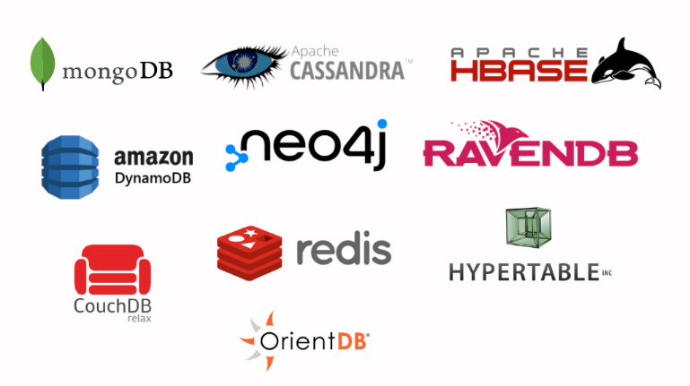**Major NoSQL providers:**

Figure 60: Source https://www.decipherzone.com/blog-detail/nosql-databases

1. **Amazon Dynamo DB**
2. **Mongo DB**
3. **Couch DB**
4. **Azure Cosmos DB**
5. **Apache Hbase**
6. **Neo4j**

**Two Major Advantages of No SQL Databases:**

1. Fields don’t have to be predefined. New fields can be created when needed.

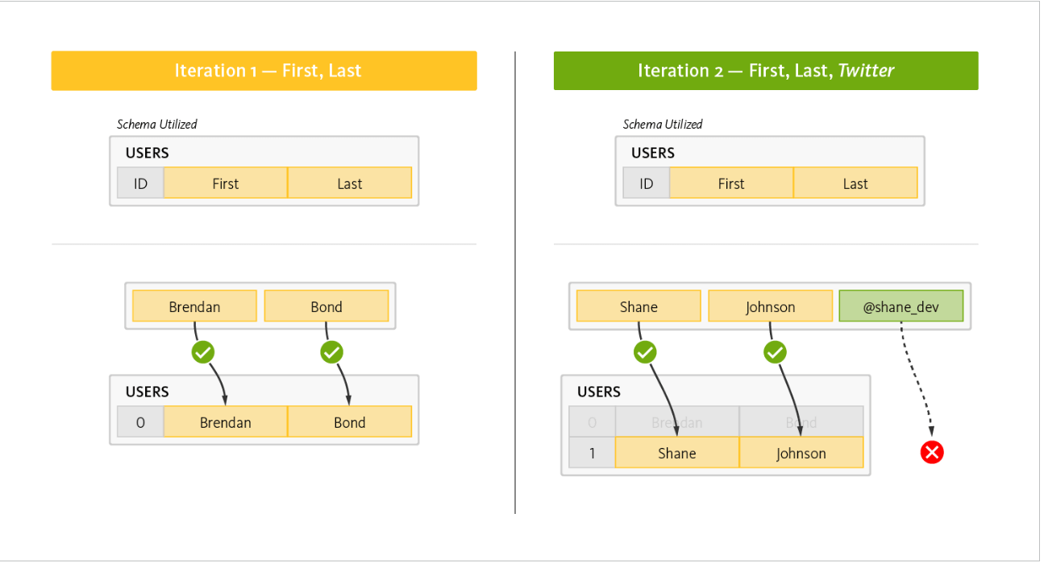

Figure 61: source <https://www.couchbase.com/resources/why-nosql/>

1. Files such as videos, audio, pdf or .jpeg could be managed and associated to storage containers. (Not covered in this lab)

## Provisioning Azure Cosmos DB NoSQL

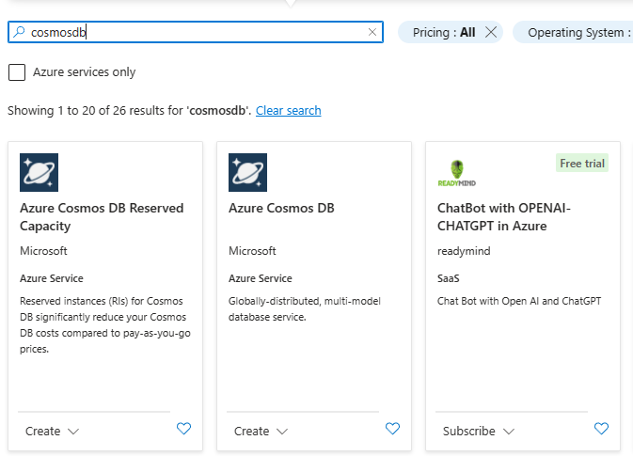

Figure ; Type Cosmo DB and select Azure Cosmo DB

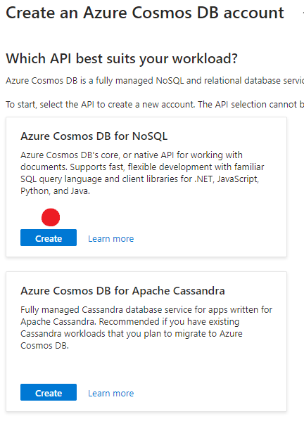

Figure : Select the NoSQL option

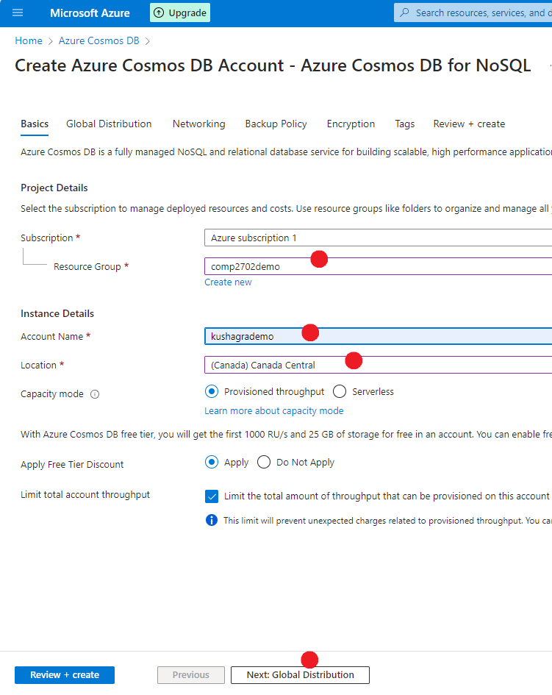

Figure : type values as needed. Any region except US East (all zones) work fine.

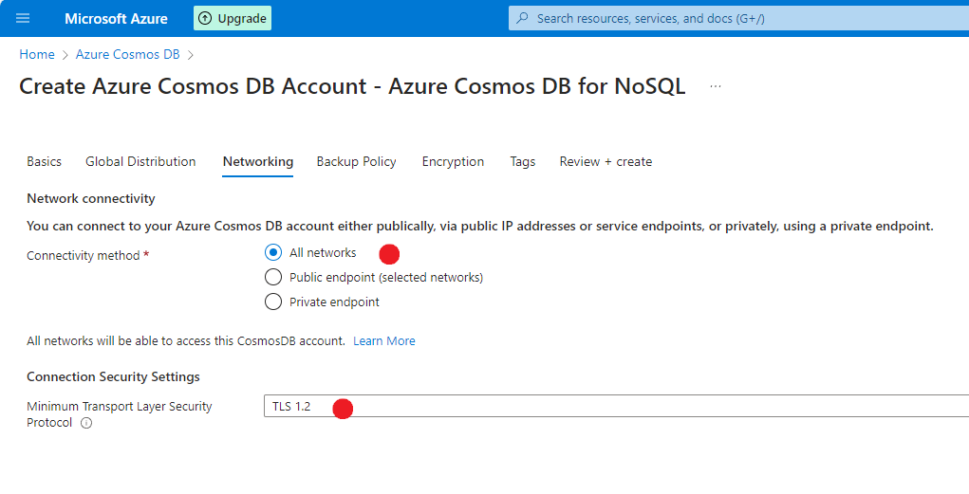

Figure : Select as shown.

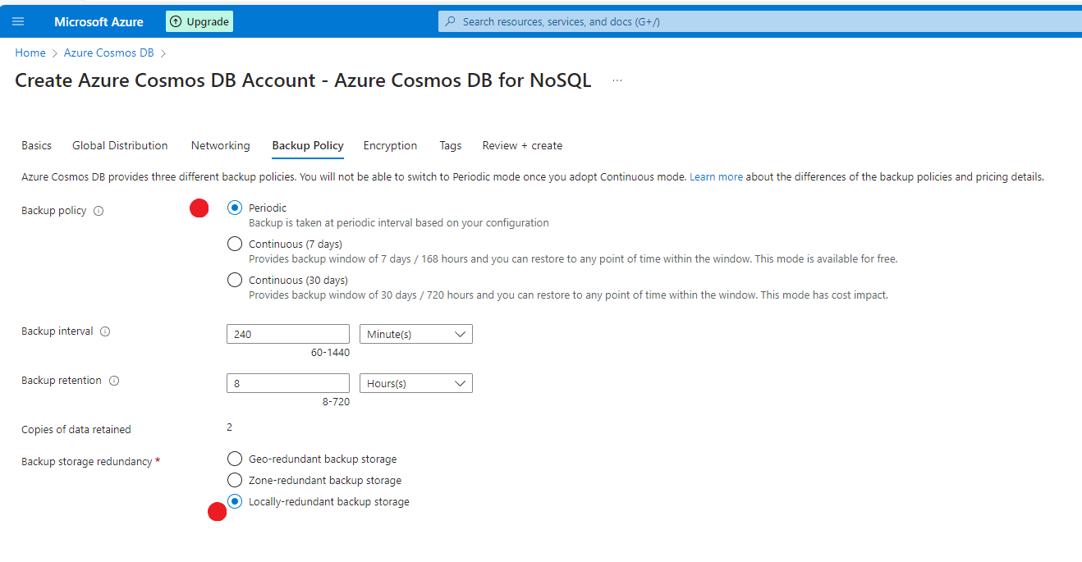

Figure : Use defaults. Change backup to locally-redundant.

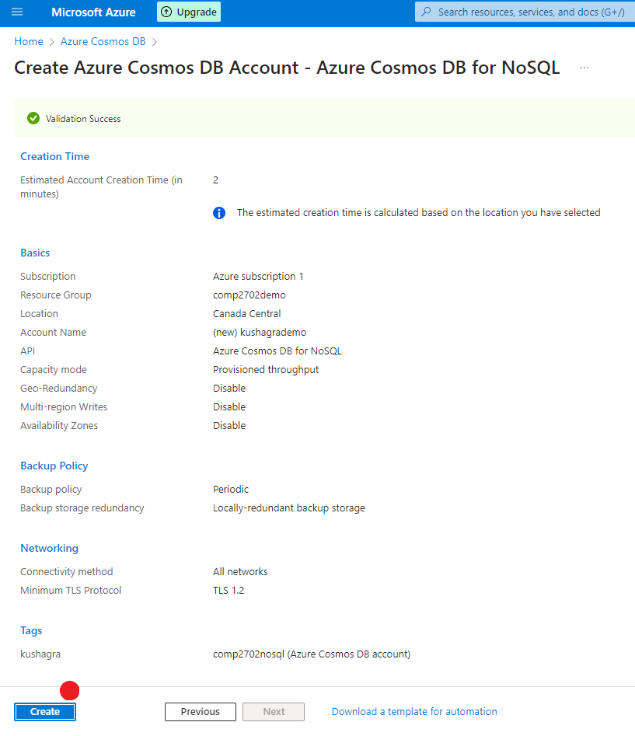

Figure : Review settings and create.

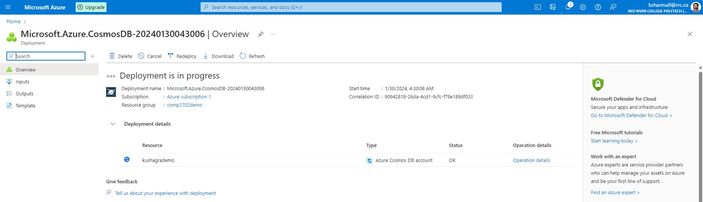

Figure :: Wait for 5 minutes.

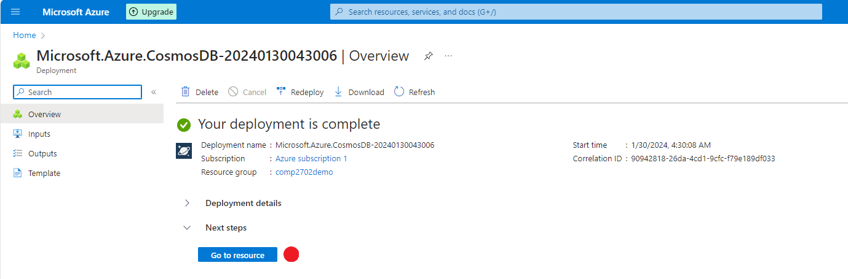

Figure

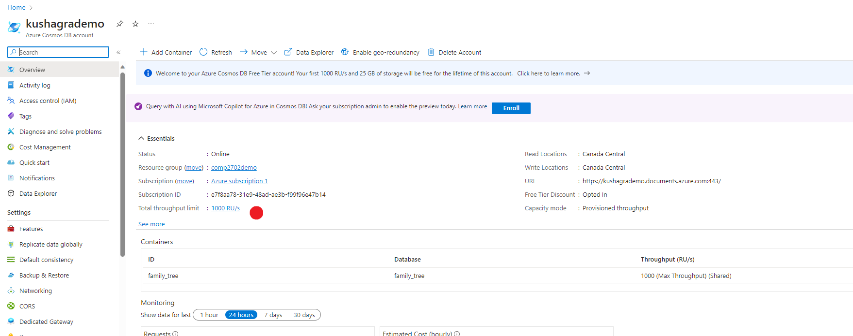

Figure : In overview, click on throughput limit. Lower throughput limit can create issues when updating/uploading larger data.

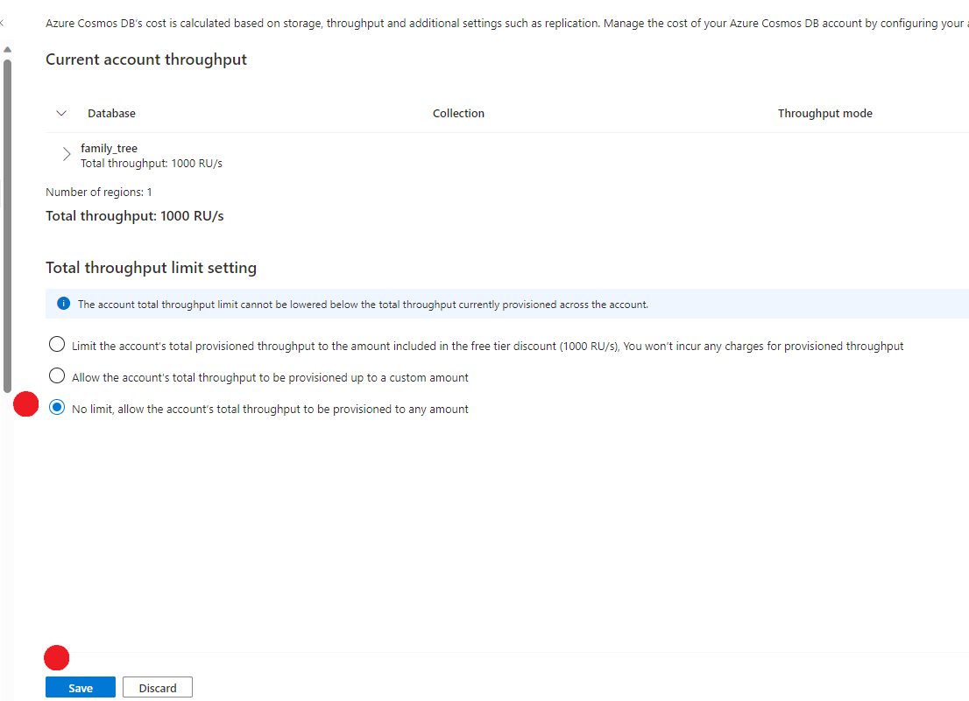

Figure : Select as shown.

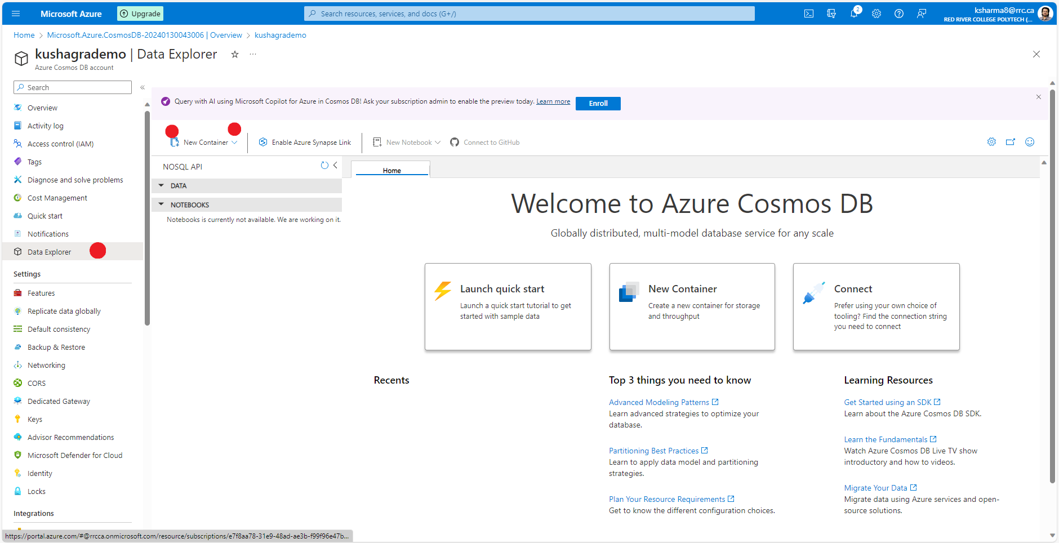

Figure : From data explorer, click on new container.

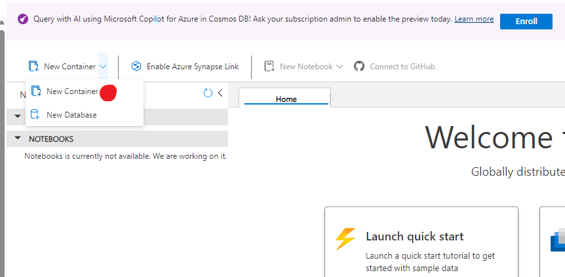

Figure : New container.

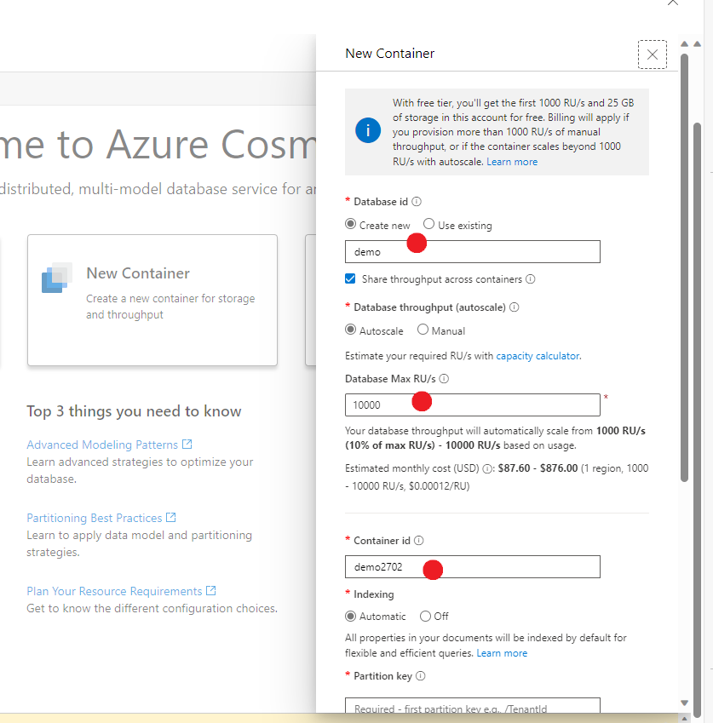

Figure : Fill details as needed.

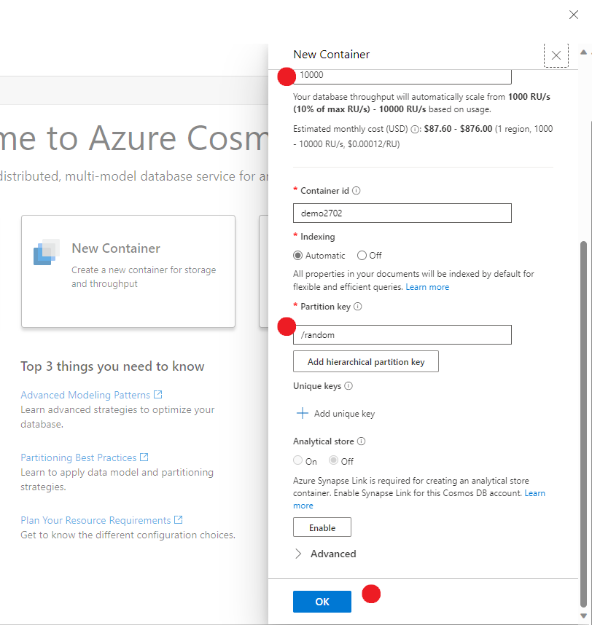

Figure : Review and click ok.

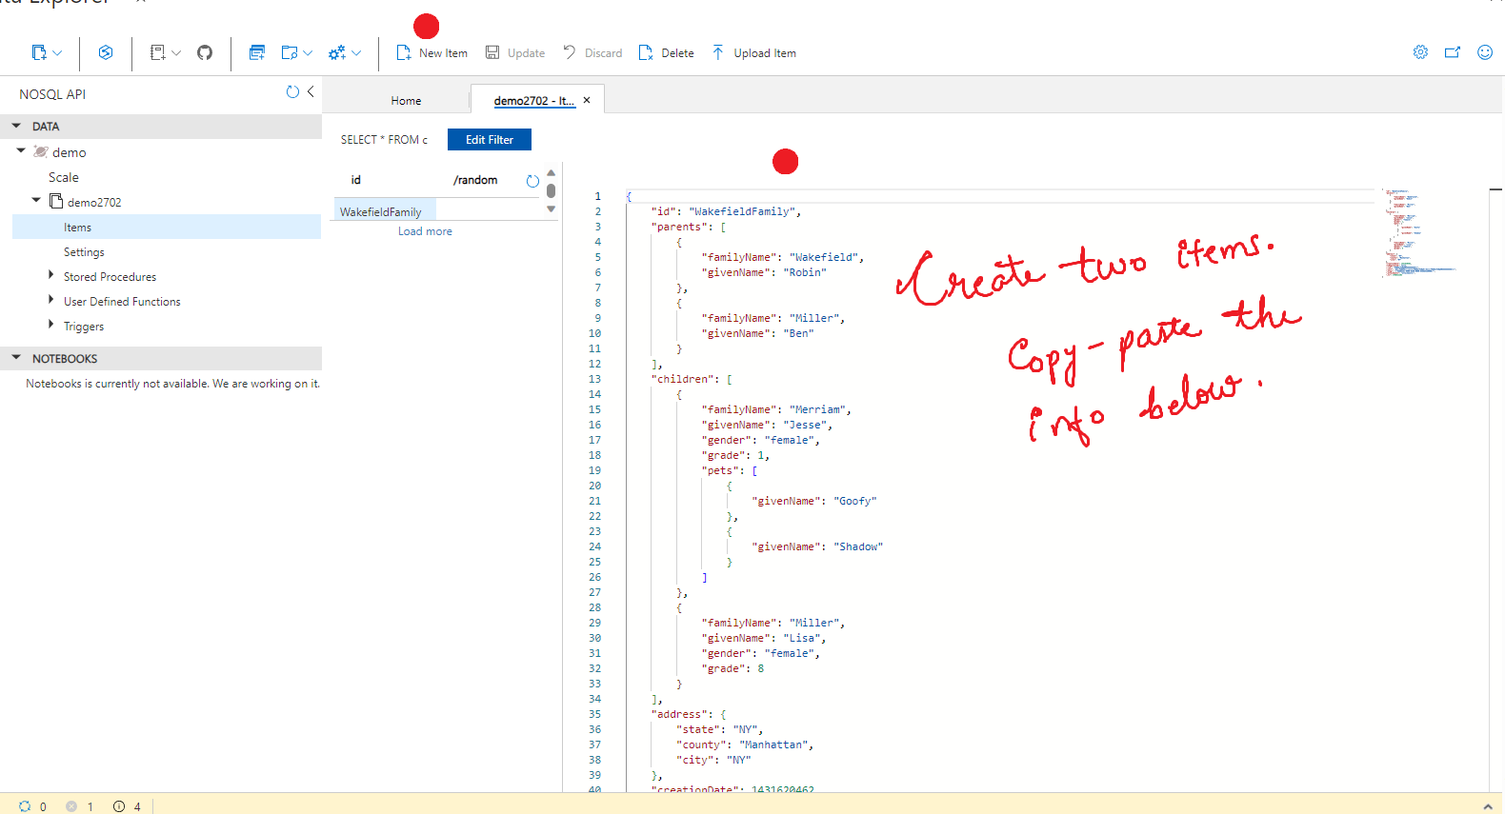

Figure : From the left panel, find Items. This is where your data will be stored. To create new data items, copy paste the code below.

### Creating data item 1:

{

"id": "WakefieldFamily",

"parents": [

{ "familyName": "Wakefield", "givenName": "Robin" },

{ "familyName": "Miller", "givenName": "Ben" }

],

"children": [

{

"familyName": "Merriam",

"givenName": "Jesse",

"gender": "female", "grade": 1,

"pets": [

{ "givenName": "Goofy" },

{ "givenName": "Shadow" }

]

},

{

"familyName": "Miller",

"givenName": "Lisa",

"gender": "female",

"grade": 8

}

],

"address": { "state": "NY", "county": "Manhattan", "city": "NY" },

"creationDate": 1431620462,

"isRegistered": false

}

### Creating data item 1:

{

"id": "AndersenFamily",

"parents": [

{ "familyName": "Andersen", "givenName": "Thomas" },

{ "familyName": "Andersen", "givenName": "Mary" }

],

"children": [

{

"familyName": "Andersen",

"givenName": "Henriette",

"gender": "female", "grade": 5,

"pets": [

{ "givenName": "Fluffy" },

{ "givenName": "Boo" }

]

},

{

"familyName": "Andersen",

"givenName": "Andrew",

"gender": "male",

"grade": 8

}

],

"address": { "state": "WA", "county": "King", "city": "Seattle" },

"creationDate": 1431620462,

"isRegistered": false

}

### Query Data

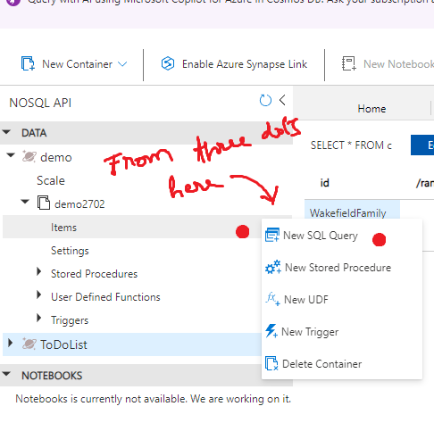

Figure : create a new SQL query window using the three dots.

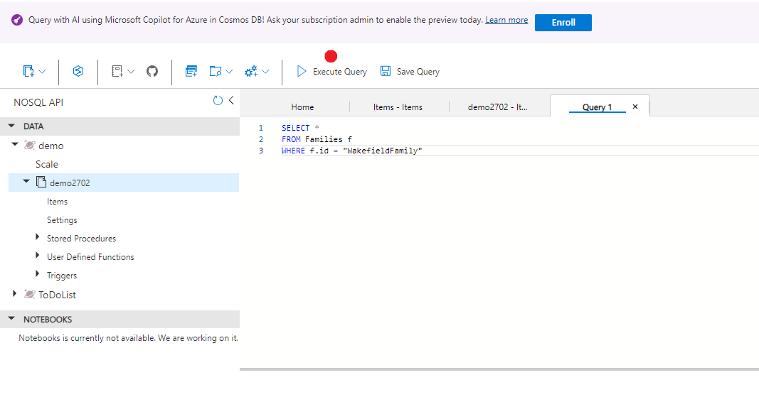

Figure : Run the queries shown below. Notice the execute query button.

SELECT *

FROM Families f

WHERE f.id = "WakefieldFamily"

Or

SELECT c.givenName

FROM Families f

JOIN c IN f.children

WHERE f.id = 'WakefieldFamily'

# **Annexure I (Budgets and Alerts)**

**Objective:** To get an alert on email when spending threshold is reached.

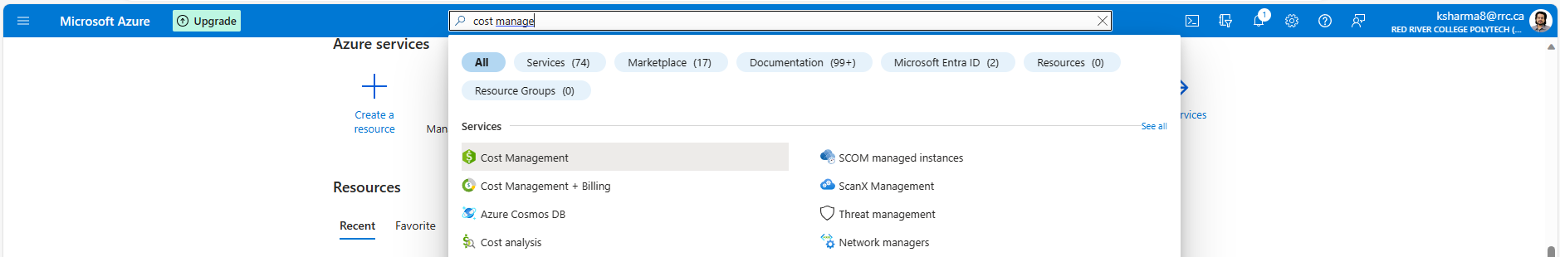

Figure 79: Search for "Cost Management + Billing"

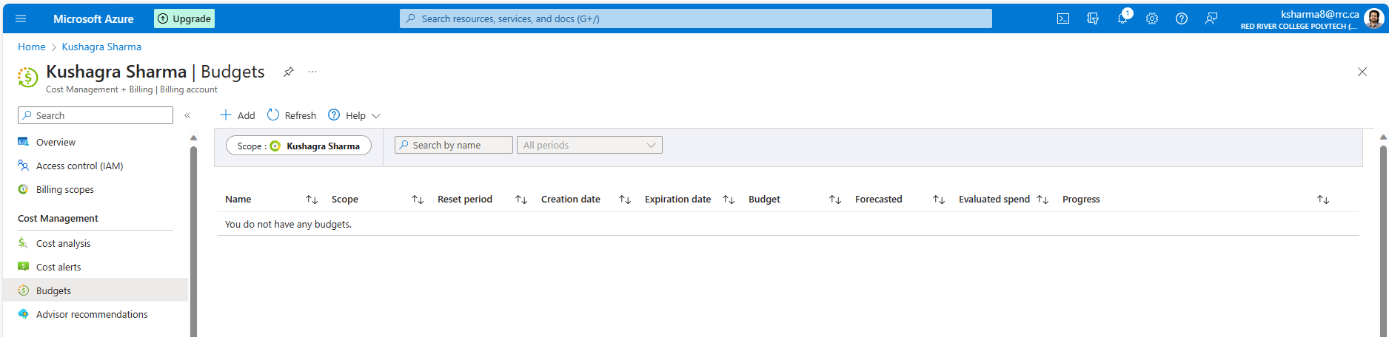

Figure 80: Go to “Budgets” and “Add” a Budget

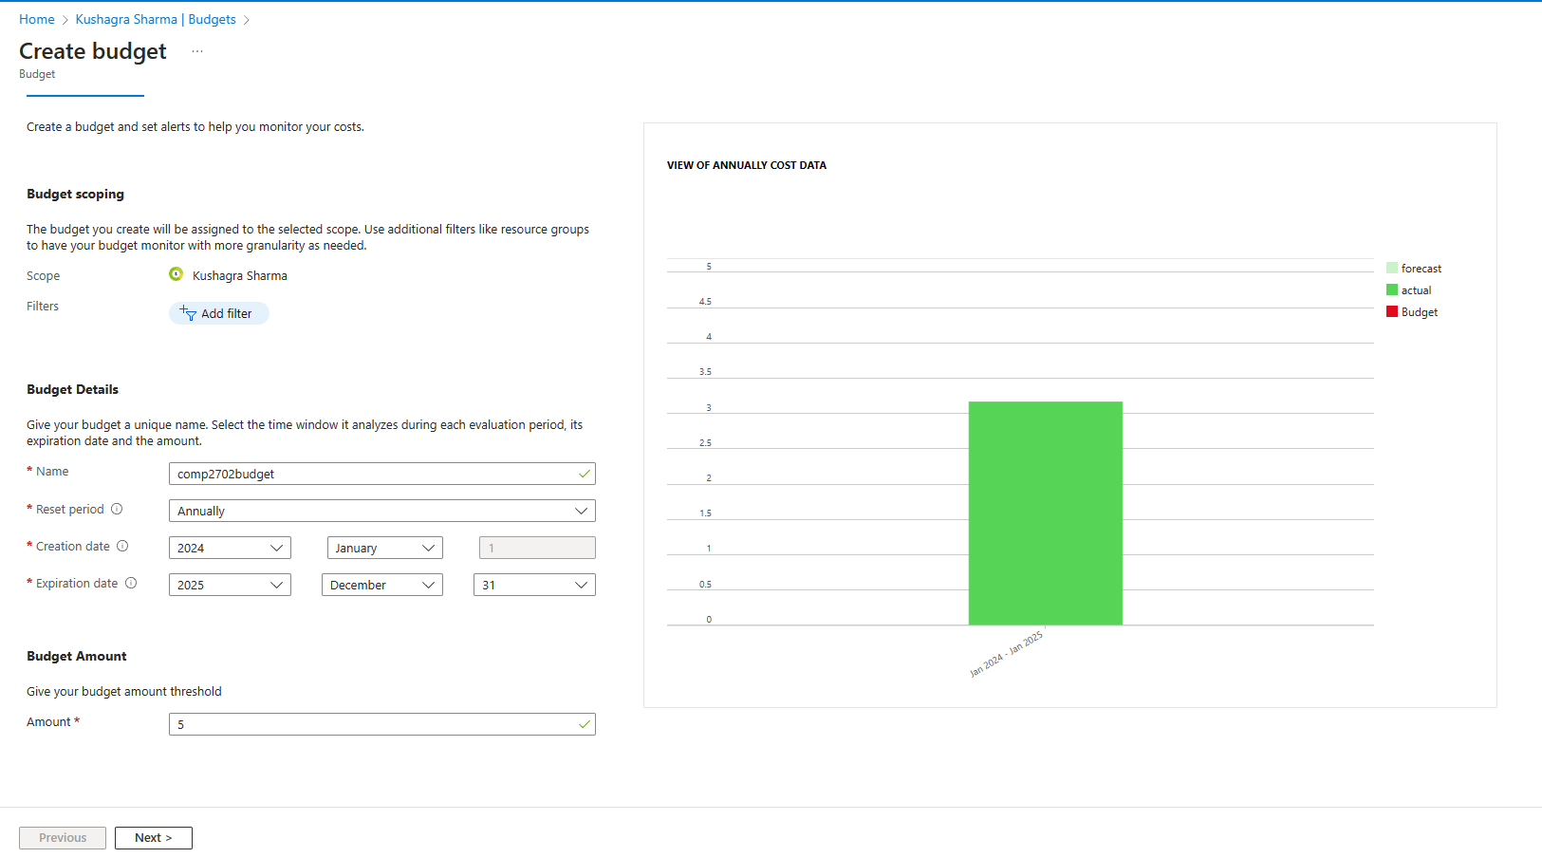

Figure 81: Fill the fields as needed. Here I am setting up a 5$ annual budget.

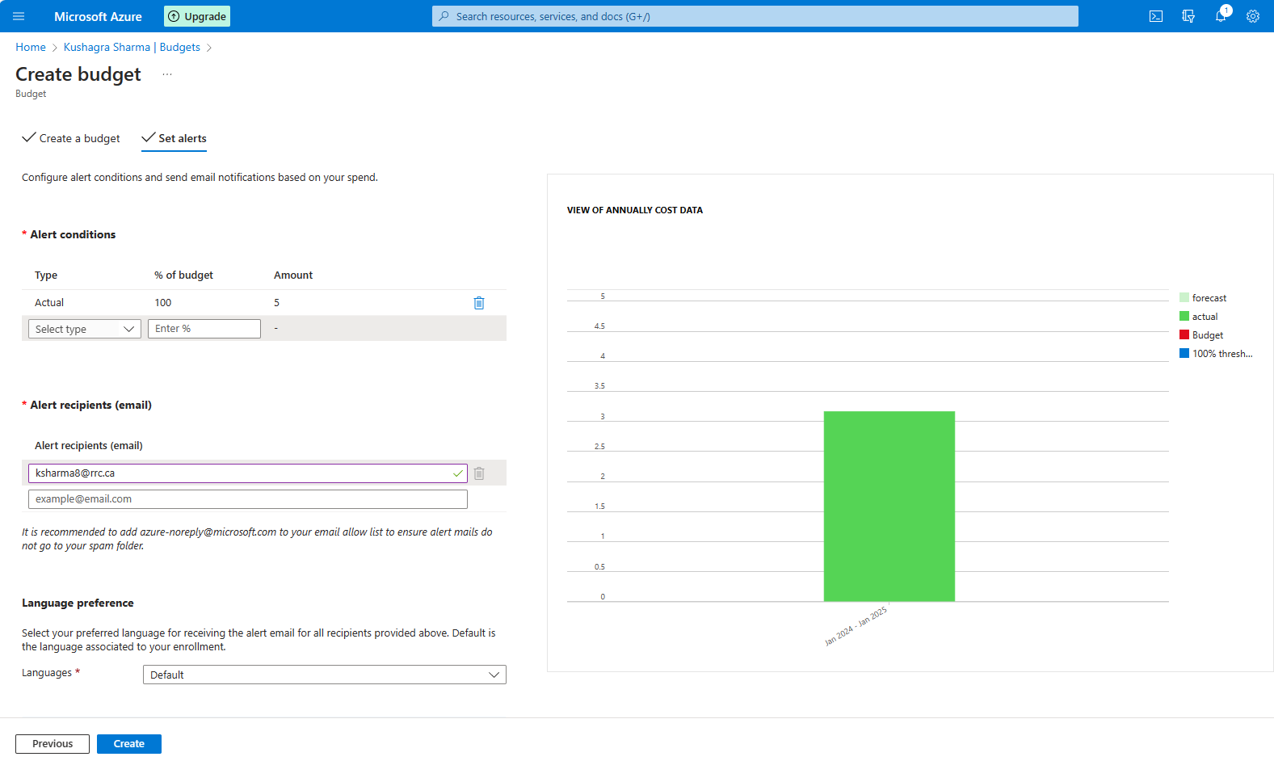

Figure 82: Fill the fields as needed. I will be notified when 100% of my 5$ budget has been exhausted. For 50%, I'll be notified at $2.5 expenditure.

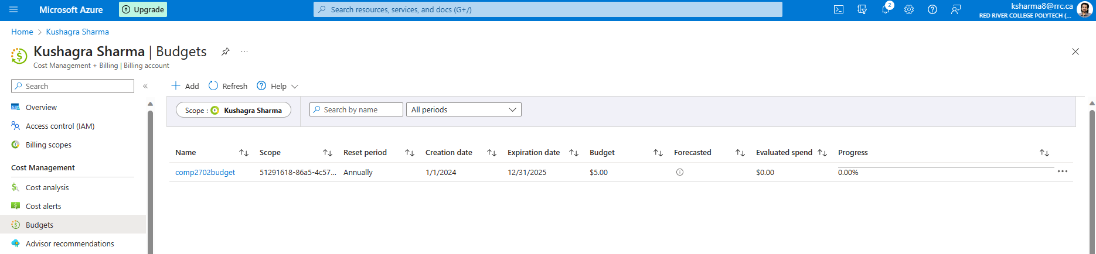

Figure 83: Your new budget shows up in the panel. It may take some time for the results to get updated.

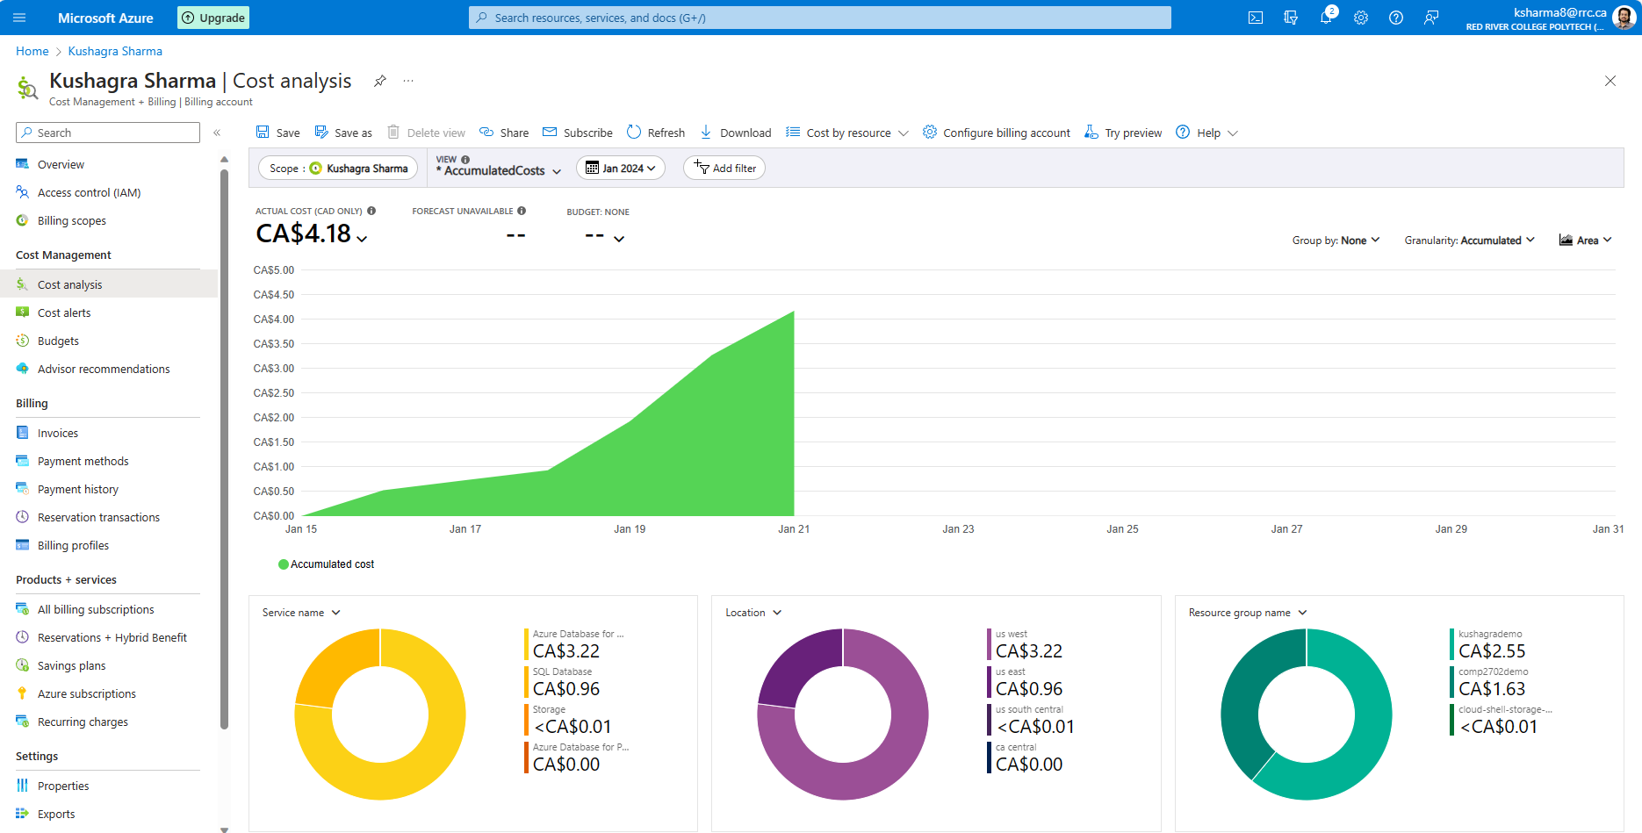

Figure 84: We can monitor our spendings in the cost analysis tab. Resource group names help us to monitor the cost incurred by a specified service or department such as finance, refunds, or human resource. Use of Names and Tags is always encouraged.

# **Annexure II (Software Installation Manual)**

## (a) DBeaver Enterprise Edition

Go to <https://dbeaver.com/academic-license/> and sign up using your RRC email address.

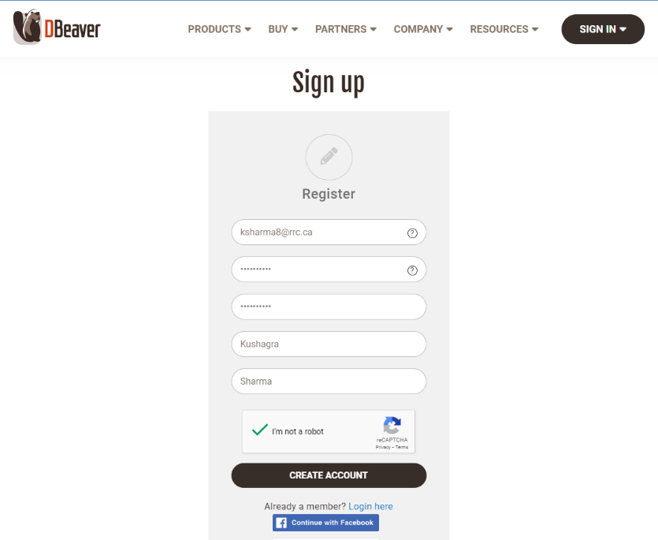

Figure 85: Sign up using RRC email address

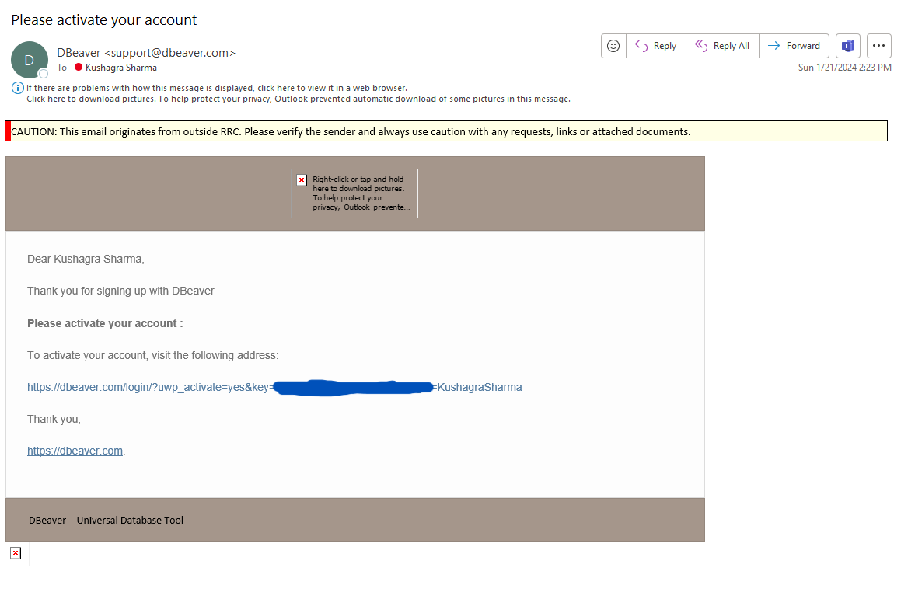

Figure 86: Check your email for activation link.

After logging into the account, go to Buy>Academic Licenses and fill up the application. In reason you can mention your status as a student and your intended use.

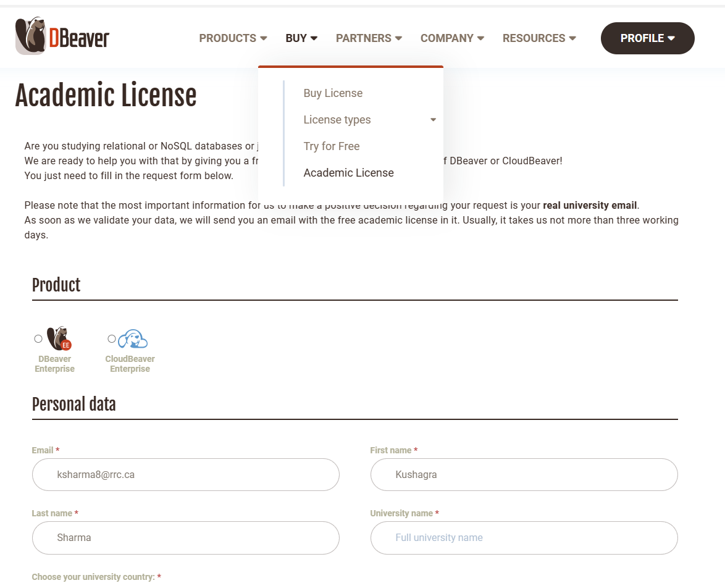

Figure 87: Fill up the details as needed

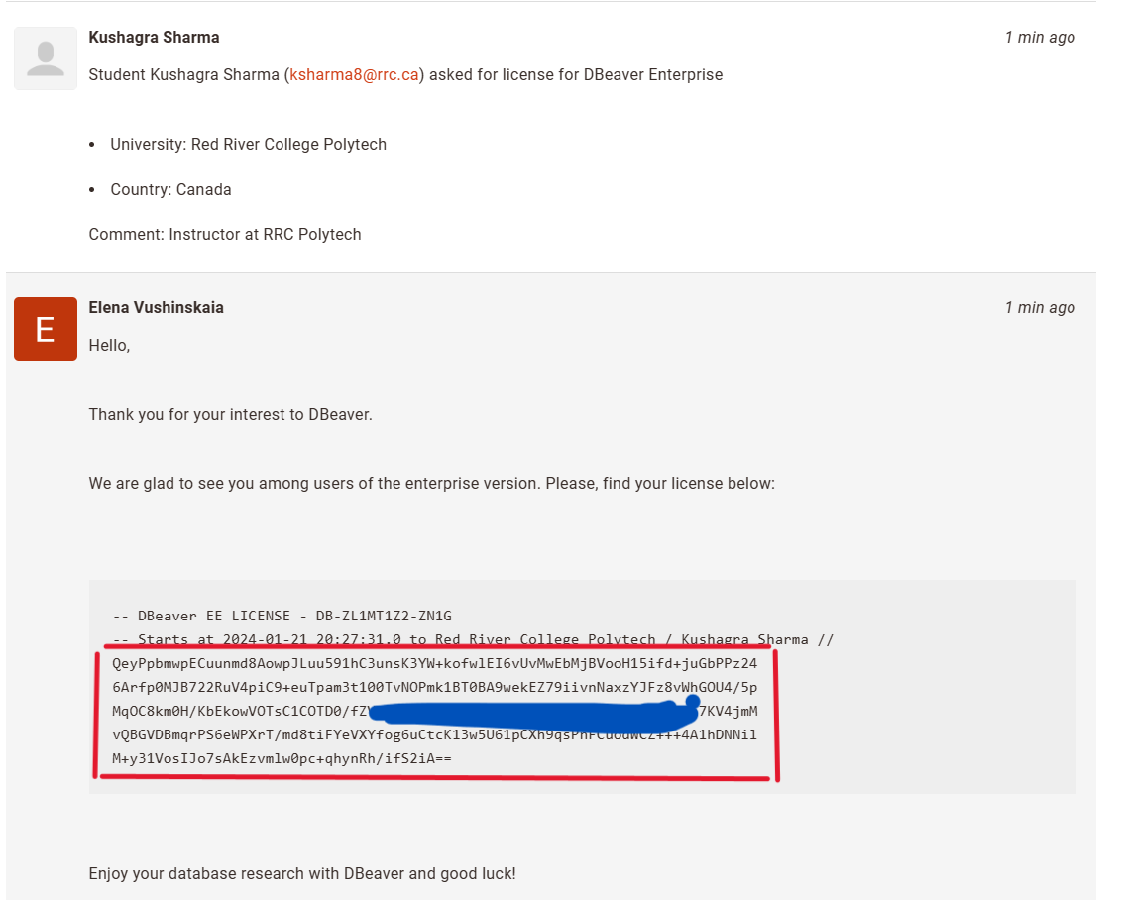

Figure 88: You may have received the activation code in your email, or you can look up for open tickets.

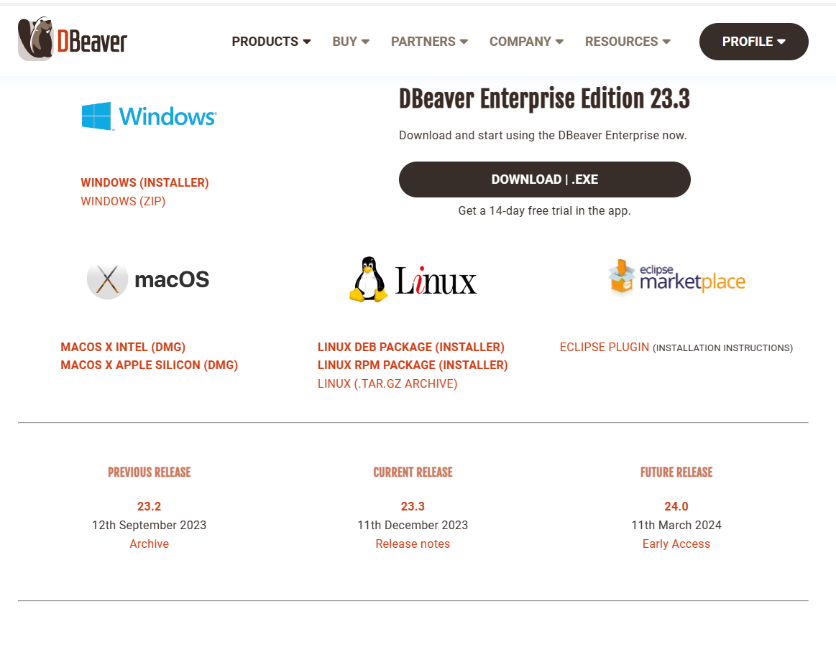

Figure 89: Download the Enterprise Edition installation file and proceed to install with the default configuration.

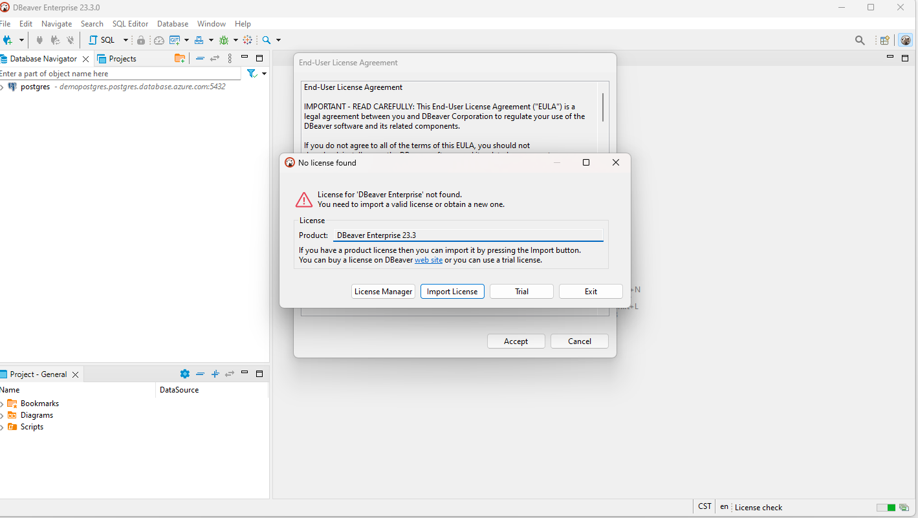

Figure 90: Click on import license and copy paste your license.

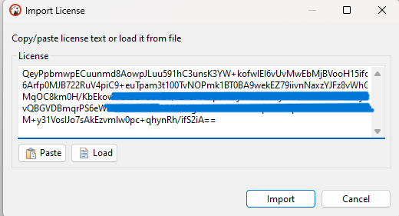

Figure 91: License copied.

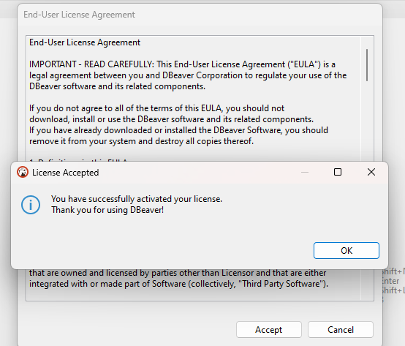

Figure 92: DBeaver Enterprise Edition is ready for use.

## (b) Microsoft SQL Server Management Studio

Use the following link to download:  
<https://aka.ms/ssmsfullsetup>

OR, visit this page for more information  
<https://learn.microsoft.com/en-us/sql/ssms/download-sql-server-management-studio-ssms?view=sql-server-ver16>

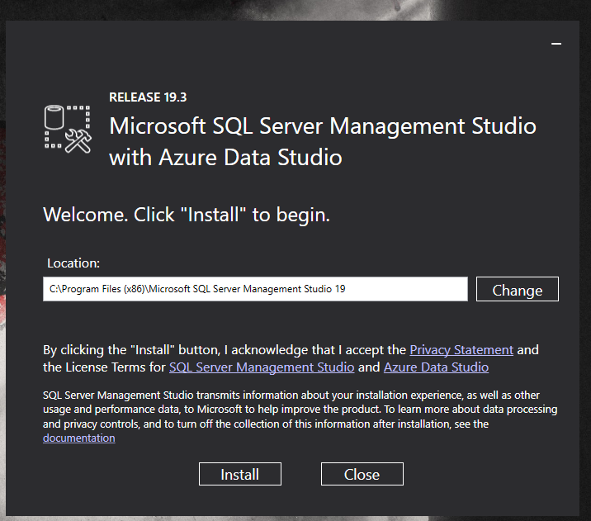

Figure 93: Install with default configuration.

## (c) MySQL Workbench

If you have MySQL community package already installed, you can search for workbench in windows search back.

To download MySQL community package, that includes MySQL Client, server, workbench, etc:   
<https://dev.mysql.com/downloads/mysql/>

To install MySQL Workbench, you can follow this link:

<https://www.mysql.com/products/workbench/>